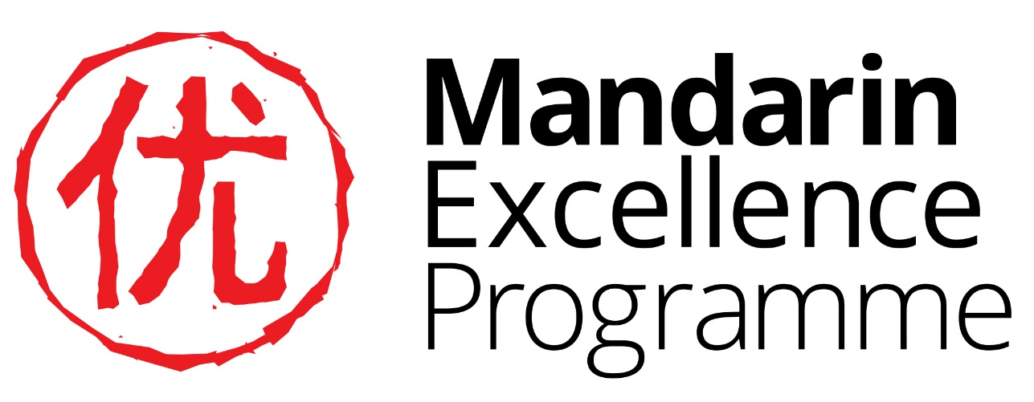

Y9 Project: More about Bubble Tea

Answers

Task 1a

|  |  |  |
| --- | --- | --- |
| 珍珠 | zhēn zhū | pearl |
| 奶 | nǎi | milk |
| 茶 | chá | tea |

Task 1b

|  |  |  |  |  |  |
| --- | --- | --- | --- | --- | --- |
|  | A | B | C | D | E |
| 1 | 玖  jiǔ |  |  | 玫  méi |  |
| 2 |  |  | 珊  shān | 瑰  guī |  |
| 3 |  |  |  | 瑾  jǐn | 琴  qín |
| 4 |  | 珀  pò |  |  |  |

Task 1c

|  |  |  |  |  |  |  |  |
| --- | --- | --- | --- | --- | --- | --- | --- |
| Co-ordinates | A 1 | D1 | C2 | D2 | D3 | E3 | B4 |
| Pinyin | jǐu | méi | shān | guī | jǐn | qín | pò |
| Meaning | Black jade | Fine jade, in the word for ‘rose’ | coral | Fine jade, in the word for ‘rose’ | Beautiful jade | A zither, in the word for piano | amber |

Task 1d

1. 现在九点 It is 9 o’clock now
2. 我喜欢玩电脑游戏I like playing computer games

Task 2a

|  |  |  |
| --- | --- | --- |
| Pinyin | Cup | English translation |
| nǎi chá sān xiōng dì | F | ‘Three brothers milk tea’ * |
| zhēn zhū nǎi chá | D | Bubble tea |
| hóng dōu nǎi chá | C | Red bean tea |
| xiān yù nǎi chá | A | Fresh taro tea |
| bù dīng nǎi chá | E | Pudding tea |
| yē guǒ nǎi chá | B | Coconut |

Task 4a

|  |  |  |
| --- | --- | --- |
| Ingredient | Chinese characters | Pin yin |
| sesame | 芝麻 | zhī ma |
| lemon | 柠檬 | níng méng |
| apple | 苹果 | píng guǒ |
| vinegar | 醋 | cù |
| durian | 榴莲 | liú lián |

Task 4b

**A durian is a large fruit with a spikey skin that grows mainly in South East Asia. The inside is sweet and custardy but it has a very strong smell that some people say smells like drains. The smell is so strong it is forbidden to take the fruit on public transport in Singapore!**

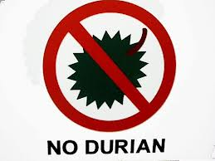

|  |  |
| --- | --- |
| Drink number | score |
| 第一个 dì yī gè | 7 |
| 第二个 dì èr gè | 7 |
| 第三个 dì sān gè | 7 |
| 第四个 dì sì gè | 8 |
| 第五个 dì wǔ gè | 8 |

Task 8a

|  |  |
| --- | --- |
| 6,500 | 六千五百 |
| 3,600 | 三千六百 |
| 8,200 | 八千两百 |
| 8,456 | 八千四百五十六 |
| 6,422 | 六千四百二十二 |
| 1,607 | 一千六百零七 |
| 9,206 | 九千二百零六 |
| 7,505 | 七千五百零五 |

Task 8b

|  |  |
| --- | --- |
| 25,500 | 两万五千五百 |
| 32,200 | 三万两千两百 |
| 93,200 | 九万三千两百 |
| 68,756 | 六万八千七百五十六 |
| 41,322 | 四万一千三百二十二 |
| 39,882 | 三万九千八百八十二 |
| 39,996 | 三万九千九百九十六 |
| 99,999 | 九万九千九百九十九 |
| 257,621 | 二十五万七千六百二十一 |

Task 8b

|  |  |  |
| --- | --- | --- |
| China | 1,397,210,000 | 十三亿九千七百二十一万 |
| India | 1,346,840,000 | 十三亿四千六百八十四万 |
| US | 329,153,000 | 三亿两千九百一十五万三千 |
| Indonesia | 268,074,600 | 两亿六千八百一十五万三千 |
| Brazil | 209,868,000 | 两亿九百八十六万八千 |
| UK (ranked 22nd) | 66,040,229 | 六千六百零四万二百二十九 |