Homes in China
Activity 1
Divide the students in pairs. Ask the pairs to match the vocabulary to each picture. Encourage the students to use the conversational vocabulary below to discuss with their partner what their favourite style of house is and why:
我最喜欢住在。。。
Conversational vocabulary
因为 | Yīnwèi | 真的 | Zhēn de
新 | Xīn | 不好看 | Bù hǎokàn
漂亮 | Piàoliang | 旧 | Jiù

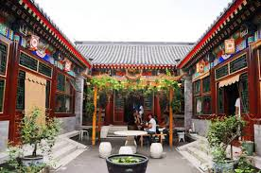
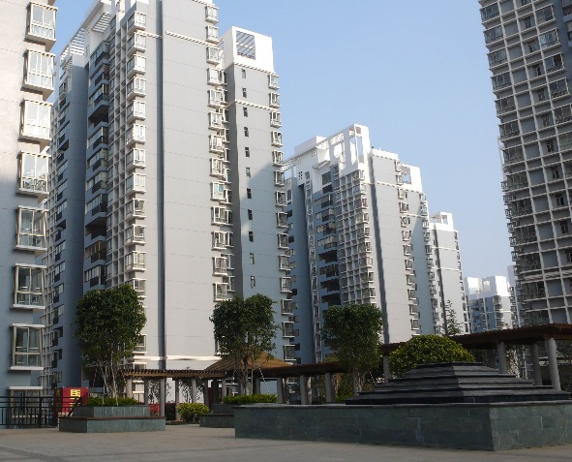

- B.
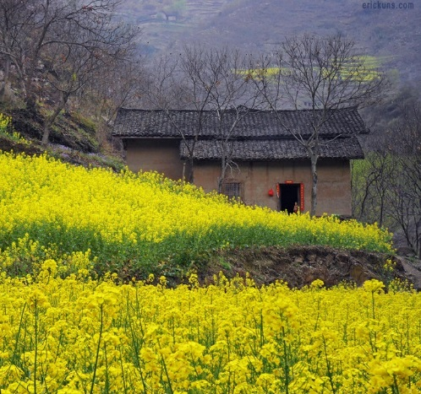
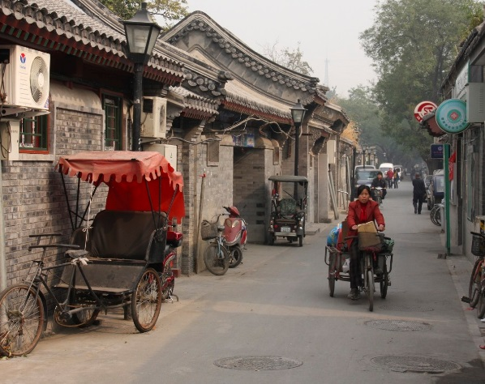

C. D.
- 四合院 Sìhéyuàn
- 农家 Nóngjiā
- 房子 Fángzi
- 胡同 Hútòng

Ask your students to read the following article about living in a courtyard house: https://www.travelchinaguide.com/cityguides/beijing/hutong/yard.htm
The following video is about the oldest hutong district in Beijing. From 16 minutes 40 seconds onwards, the video looks inside a courtyard residence: https://www.youtube.com/watch?v=bGazhbTcwyI

Activity 2
Design your own courtyard home!
Ask your students to use the list of vocabulary below to design how their own courtyard style house (see template on P4)…
Students can revise their family member vocabularly by labelling their family members’ bedrooms in their courtyard house.

Vocabulary
卧室 | Wòshì | 花园 | Huāyuán
厨房 | Chúfáng | 大门 | Dàmén
客厅 | Kètīng | 浴室 | Yùshì
门 | Mén | 游戏室 | Yóuxì shì

Activity 3
Divide the class into pairs and give each pair two blank house templates. The aim of the activity is for the students to describe the house they designed in activity two to their partner and for their partner to correctly label it on the blank template. Use the directional vocabulary below for this activity.

Vocabulary
右边 | Yòubiān | 第一个 | Dì yī gè
左边 | Zuǒbiān | 前边 | Qiánmiàn
后面 | Hòumiàn

Courtyard House Template for Activity 2
