Hi

How old are you
你多大？
nǐ duō dà？
Instruction：
You will get a picture with some words of the family members. Work in pairs.
1. Ask about your partner’s age.
2. Take turns to introduce at least 3 family members’ age to your partner, then record your partner’s family members’ age on page 2 according to what you hear.
If you cannot hear your partner’s introduction clearly, you can use the sentence below to ask that age again.
e.g.你 多大？
nǐ duō dà？
3. Fill in the gaps with pinyin and/or Chinese Characters on page 3.

1. According to what you hear from your partner, write down the person’s age on the picture below.
Maternal grandmother
Maternal grandfather
Paternal grandmother
Paternal grandfather
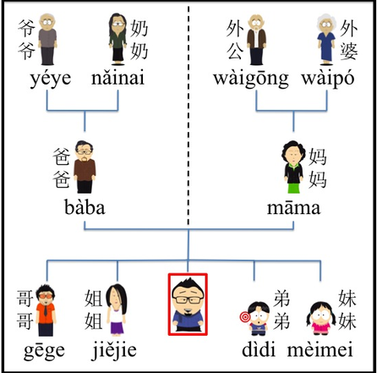

Mother
Father

我 wǒ

Younger sister
Younger brother
Older sister
I
Older brother

2.According to the conversation, complete those sentences below.
(1)-A: duō dà?
你 ？
-B: wǒ shíèr suì.
我 。
(2) -A: nǐ māmɑ ?
你 多大？
-B: wǒ suì.
妈妈 四 十 七 岁。
（3）-A: nǐ duō dà?
姐姐 大？
-B: jiějie shíbā suì.
我 。

Key:
2. (1) -A: nǐ duō dà?
你 多 大 ？
-B: wǒ shíèr suì.
我 十二 岁 。
(2) -A: nǐ māmɑ duō dà ?
你 妈妈 多大？
-B: wǒ māmɑ sìshíqī suì.
我 妈妈 四十七 岁。
(3) -A: nǐ jiějie duō dà?
你 姐姐 多 大？
-B: wǒ jiějie shíbā suì.
我 姐姐 十八 岁 。

