Project 11: The People and Language of China
This project introduces some of the ethnic diversity in China to students, through a look at four different groups- the Miao, the Zhuang, The Uyghurs and the Hui. Students have to search on the internet to discover the ethnic groups of China, and then use language skills to describe where some of them live geographically (links to the project “The Land that is China”) before learning more about those four specific groups. They then listen to some of the different languages of China, and answer a general quiz about Mandarin language before writing about two languages spoken in China that they like. The structure 除了noun 1, subject 还 verb + noun 2 is introduced, and students practice, before watching a video of Gao Laoshi talking about regional differences of language in China.

Difficulty
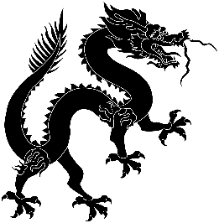

Predicted Duration
3hr 10 minutes
Series Type
Technology

Key Language
人口 rén kǒu | population
汉语 hàn yǔ | Chinese
汉字 hàn zì | Chinese characters
族 zú | minority group
东 dōng | east
西 xī | west
南 nán | south
北 běi | north
苗族居 miáo zú jū | Miao ethnic group
维族居 wéi zú jū | Uyghur ethnic group
回族居 huí zú jū | Hui ethnic group
住 zhù | to live
国语 guó yǔ | national language
普通话 pǔ tōng huà | Mandarin
中文- zhōng wén | Chinese
会说 huì shuō | able to speak
除了…还 chúle…hái… | apart from…also
喜欢 xǐhuan | to like

Task number | Estimated time to complete (mins)
1 | 10
2 | 30
3 | 30
4 | 30
5 | 45
6 | 40
7 | 20
8 | 20
9 | 15
10 | 15
11 | 10
Total time | 265 (4 hr 25 m)

