Project 12: Chinese Literature
Students begin to develop their translation and literary skills further in this project, through the structured language of poems and a short story. This is a vocabulary-dense topic, with a lot of new language introduced, so teachers might like to divide up (perhaps focus on the poems first, then the story at a later date), which highlights to students the difference between literal direct translation, and the need to interpret language to find a suitable English alternative.
Difficulty
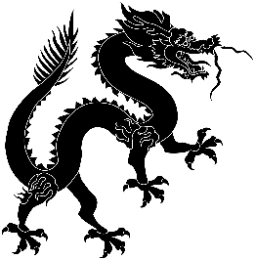

Predicted Duration
4hr 20 minutes
Series Type
Culture

Key Language
鸡 jī | chicken
蛋 dàn | egg
生 shēng | to give birth/ to hatch
到底 dào dǐ | in the end/finally
有 yǒu | to exist/there is
当然 dāng rán | of course
一定 yí dìng | for sure/definitely
不一定 bù yí dìng | not necessarily
先 xiān | first
才cái | only then
硬币 yìng bì | coin
年轻人 nián qīng rén | young people
找 zhǎo | to look for
躺 tǎng | to lie down
看也不看 kàn yě bú kàn | not even look
激动地 jī dòng de | excitedly
捡起 jiǎn qǐ | to pick up
心里想 xīn lǐ xiǎng | think of oneself
没出息 méi chū xi | (someone) has no future/ good for nothing

Task number | Estimated time to complete (mins)
1 | 5
2 | 45
3 | 20
4 | 90
5 | 60
6 | 10
7 | 30
Total time | 260 (4hr 20 m)

Key Language
白白地 bái bái de | in vain/fruitless
溜走 liū zǒu | to slip away
工资 gōng zī | salary/wages
留 liú | to stay
经理 jīng lǐ | manager
还 hái | still
发财 fā cái | to make a fortune
绅士般地shēn shì bān de | elegantly/like a gentleman
免费 miǎn fèi | free
依 yī | to lean on/to depend on
尽 jìn | finished/to the limit
欲 yù | to wish/to desire
穷 qióng | the entire/ the extreme
里 lǐ | measurement of length (approx. 500m)
目 mù | to see/eye
上shàng | to go up

