Project 3: The First Emperor and the Terracotta Army
Difficulty
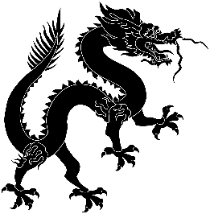

Predicted Duration
3hr 25 minutes
Series Type
History
This project introduces students to the First Emperor and the history of the Terracotta Army, via (English) articles and a documentary. Students answer comprehension questions and think about their opinion, learn about Xi’an’s location, look up some characters around the topic and practising writing them. Students are introduced to the use of 的 in combination with adjectives.

Key Language
历史 lì shǐ | history
秦 Qín | Qin
始 shǐ | start/beginning
皇帝 huáng dì | Emperor
开始 kāi shǐ | to start
兵马俑 bīng mǎ yǒng | Terracotta Warrior
西安 Xī’ān | Xi’an
东西 dōng xi | things
有趣 yǒu qù | interesting
红色 hóng sè | red
上衣 shàng yī | jacket
Adjective + 的 + Noun

Task number | Estimated time to complete (mins)
1 | 35
2 | 25
3 | 20
4 | 40
5 | 10
6 | 10
7 | 15
8 | 20
9 | 30
Total time | 205 (3 hr 25 m)

