Project 6: The Land that is China
This project develops understanding of the geography of China, looking at natural land formations and barriers (plateaus, rivers, mountains, deserts) and the neighbours surrounding China and then placing them on a map of China. Students investigate vocabulary around this topic, working out the characters and pinyin for the English words provided. Students learn the four directions, and how to combine them to say north-east etc. Students then investigate the province names of China, to work out which ones have names from nature (eg 山东). Finally, students face a stretching task of looking at the climate and weather, learning new vocabulary, looking at a Chinese weather site and copying out the weather details before translating (this task can be easily omitted and used at a later date if more appropriate).
Difficulty
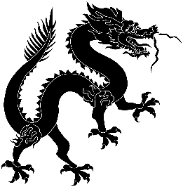

Predicted Duration
4hr 30 minutes
Series Type
Geography

Key Language
东 dōng | east
西 xī | west
南 nán | south
北 běi | north
部 bù | part
省 shěng | province
河 hé | river
江 jiāng | river
川 chuān | river/creek
湖 hú | lake
海 hǎi | sea
云 yún | cloud(s)
青 qīng | green/blue
山 shān | mountain
陕 shǎn | mountain pass

Task number | Estimated time to complete (mins)
1 | 45
2 | 20
3 | 30
4 | 20
5 | 10
6 | 15
7 | 30
8 | 20
9 | 40
10 | 20
11 | 20
Total time | 270 (4hr 30 m)

Key Language (continued)
黑 hēi | black
龙 lóng | dragon
转 zhuǎn | change, to turn into
雨 yǔ | rain
晴 qīng | sunny
雪 xuě | snow
风 fēng | wind
雾 wù | fog
小雪 xiǎo xuě | light snow
微风 wēi fēng | breeze
东南风 dōng nán fēng | south easterly wind
小雨 xiǎo yǔ | light rain
大雨 dà yǔ | heavy rain
阵雨 zhèn yǔ | light shower
多云 duō yún | cloudly
霾 mái | hazy
阴 yīn | overcast
黄山 huáng shān | Huangshan

