Project 8: Comic (Manhua)
The project introduces students to a popular culture aspect of China, the role of comics or 漫画。Students create their own cartoons either based on vocabulary based on language learnt in the classroom. A more challenging task asks students to develop more of a story (scenarios are given), and key vocabulary is provided. NB using the comic strip creation website links can be fiddly, so you may prefer to encourage students to hand draw (the focus is on the language creation more than beautiful art!). This is a project that is best marked by the teacher, and would work well as collaborative assignments in pairs.
Difficulty
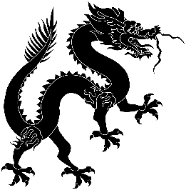

Predicted Duration
3hr 5 minutes
Series Type
Personal/Culture

Key Language
漫画 màn huà | comic/cartoon/manga
什么 shén me | what
为什么 wèi shén me | why
因为 yīn wèi | because
我知道 wǒ zhī dao | I know
我不知道 wǒ bù zhī dao | I don’t know
我想吃 wǒ xiǎng chī | I want to eat
我不想去 wǒ bù xiǎng qù | I don’t want to go
不要 bú yào | don’t/ don’t want
好 hǎo | alright/OK
对不起 duì bù qǐ | sorry
没关系 méi guān xi | don’t worry
谢谢xiè xie | thank you
不客气bú kè qi | you’re welcome
你去哪儿？nǐ qù nǎr? | where are you going?
在哪里？zài nǎ lǐ? | where is (it)?
哈哈hā hā | haha, laughing out loud
呵呵hē hē | hee hee, (sound of chuckling)

Task number | Estimated time to complete (mins)
1 | 15
2 | 30
3 | 30
4 | 20
5 | 30
6 | 60
Total time | 185 (3 hrs 5 mins)

Key Language (continued)
棒bàng | brilliant, awesome
酷kù | cool
真的吗？zhēn de ma? | really?
真的zhēn de | (yes) really
了 le | past tense usage
要yào | future tense usage
太…了tài…le | extremely

