

**H O L I D A Y T Y P E S**

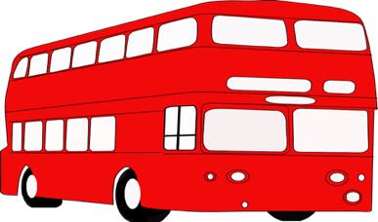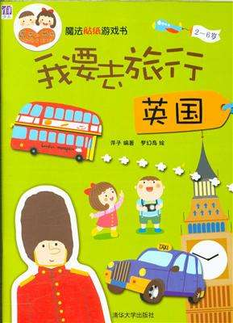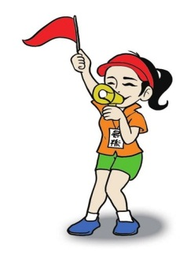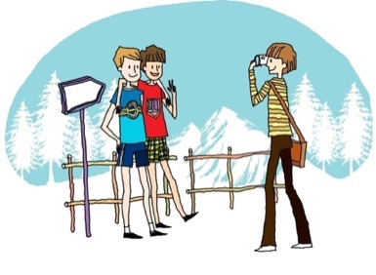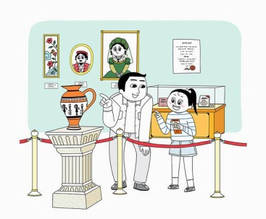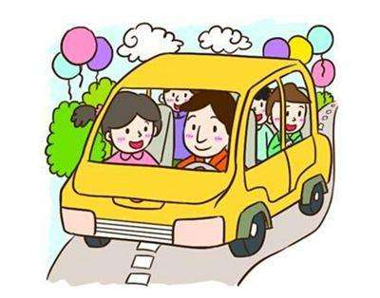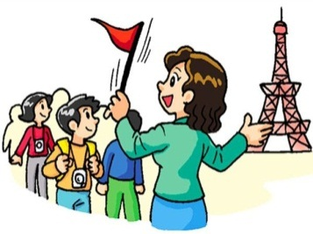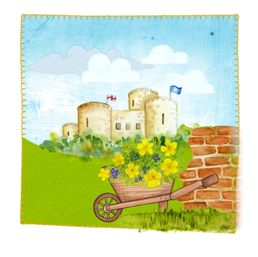

**观光旅行 guānguāng lǚxíng**

Match the pictures with the words below. Then choose at least 4 words to tell a story about your journey.

**A.** **B.** **C.**

**D.** **E.** **F.**

**G.** **H.**

**1. 跟团游 gēn tuán yóu ( ) 2. 导游 dǎoyóu ( )**

**3. 观光游 guānguāng yóu ( ) 4. 大巴 dàbā ( )**

**5. 导游书 dǎoyóu shū ( ) 6. 照相 zhàoxiàng ( )**

**7. 博物馆 bówùguǎn ( ) 8. 遗址 yízhǐ ( )**

**Contributed by Weiwei Wang, St. George’s School Confucius Classroom, UCL IOE Confucius Institute, UK**

**Copyright: All pictures were taken from the internet. I do not claim ownership of any of the images posted.**

**Cannot be published to public. Only use for personal learning, teaching and communication.**



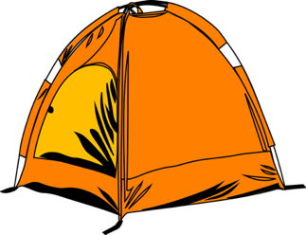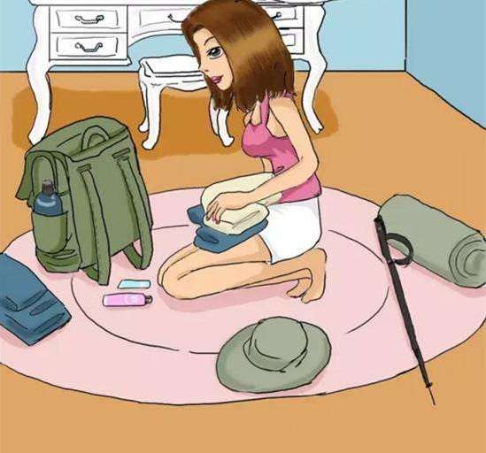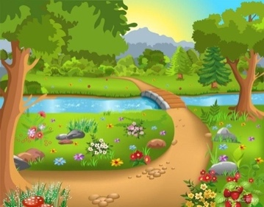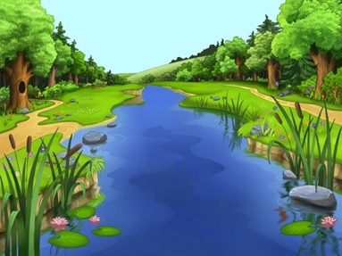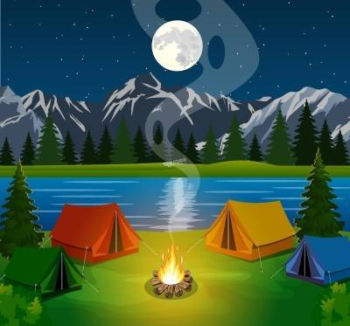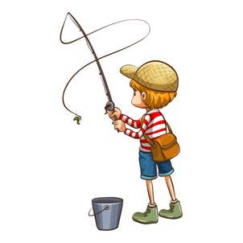

**野营 yěyíng**

Match the pictures with the words below. Then choose at least 4 words to tell a story about your journey.

**A. B. C.**

**D. E. F.**

**G. H.**

**1. 打包 dǎbāo ( ) 2. 野营地 yěyíng dì ( )**

**3. 帐篷 zhàngpéng ( ) 4. 睡袋 shuìdài ( )**

**5. 指南针 zhǐnánzhēn ( ) 6. 森林 sēnlín ( )**

**7. 河流 héliú ( ) 8. 钓鱼 diàoyú ( )**

**Contributed by Weiwei Wang, St. George’s School Confucius Classroom, UCL IOE Confucius Institute, UK**

**Copyright: All pictures were taken from the internet. I do not claim ownership of any of the images posted.**

**Cannot be published to public. Only use for personal learning, teaching and communication.**



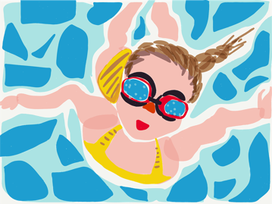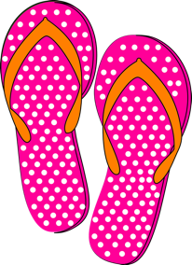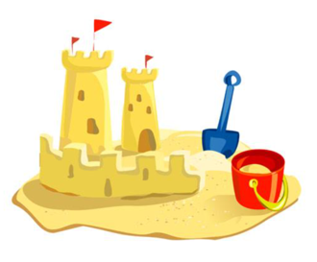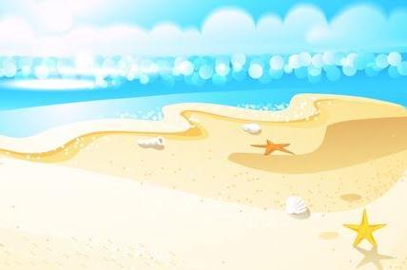

**海滩度假 hǎitān dùjià**

Match the pictures with the words below. Then choose at least 4 words to tell a story about your journey.

**A. B. C.**

**D. E. F.**

**G. H.**

**1. 日光浴 rìguāngyù ( ) 2. 游泳 yóuyǒng ( )**

**3. 沙滩城堡 shātān chéngbǎo ( ) 4. 沙滩 shātān ( )**

**5. 游泳衣 yóuyǒngyī ( ) 6. 毛巾 máojīn ( )**

**7. 冰激凌 bīngjīlíng ( ) 8.人字拖 rénzìtuō ( )**

**Contributed by Weiwei Wang, St. George’s School Confucius Classroom, UCL IOE Confucius Institute, UK**

**Copyright: All pictures were taken from the internet. I do not claim ownership of any of the images posted.**

**Cannot be published to public. Only use for personal learning, teaching and communication.**



**户外运动 hùwài yùndòng**

Match the pictures with the words below. Then choose at least 4 words to tell a story about your journey.

**A. B. C.**

**D. E.**

**F. G. H.**

**1. 冲浪 chōnglàng ( ) 2. 潜水 qiánshuǐ ( )**

**3. 划独木舟 huá dúmùzhōu ( ) 4. 骑马 qí mǎ ( )**

**5. 滑翔伞 huáxiáng sǎn ( ) 6. 爬山 páshān ( )**

**7. 蹦极 bèngjí ( ) 8. 攀岩 pānyán ( )**

**Contributed by Weiwei Wang, St. George’s School Confucius Classroom, UCL IOE Confucius Institute, UK**

**Copyright: All pictures were taken from the internet. I do not claim ownership of any of the images posted.**

**Cannot be published to public. Only use for personal learning, teaching and communication.**

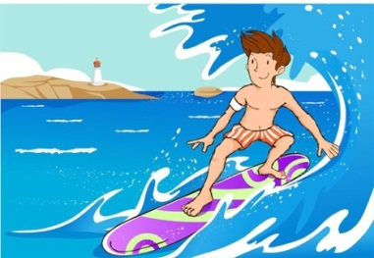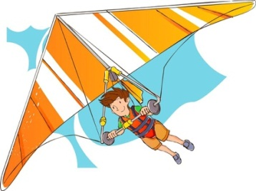

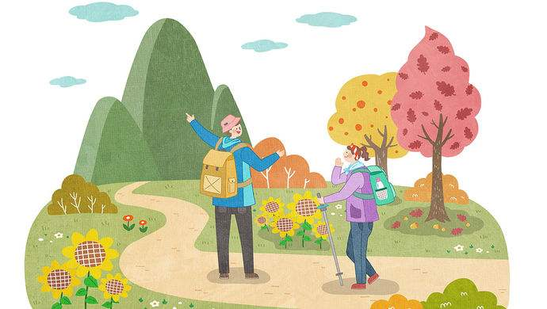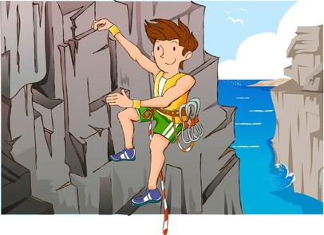

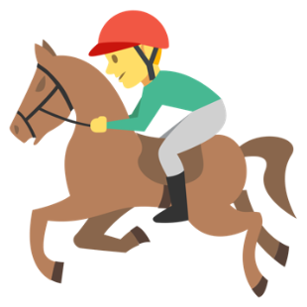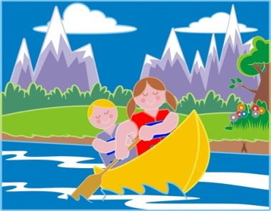

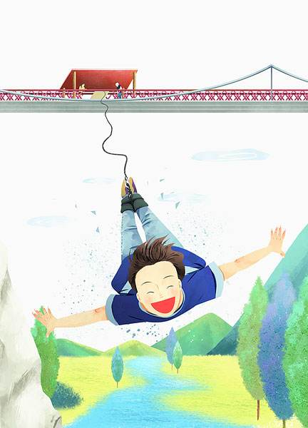



**Key:**

**Type 1 观光旅行 guānguāng lǚxíng**

**1. A 2. E 3. D 4. C 5. B 6. H 7. G 8. F**

**Type 2 野营 yěyíng**

**1. C 2. B 3. D 4. E 5. F 6. G 7. H 8. A**

**Type 3 海滩度假 hǎitān dùjià**

**1. G 2. H 3. B 4. C 5. B 6. H 7. G 8. F**

**Type 4 户外运动 hùwài yùndòng**

**1. C 2. B 3. F 4. H 5. A 6. D 7. G 8. E**