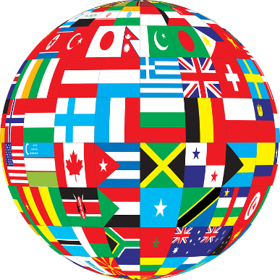
一个新国家

In small groups, imagine you could create a completely new country made up of the best things from at least five other countries.

这个国家叫什么名字？

What would this country be like? Write down your ideas.

想一想：

它的天气：______________________________________________________________

它的食物：______________________________________________________________

它的语言：______________________________________________________________

它的景色：______________________________________________________________

它的动物：______________________________________________________________

它的首都：______________________________________________________________

其他：__________________________________________________________________

________________________________________________________________________

Present your new country to the rest of the class.
To start: 我的新国家叫做 xxx 它的天气温暖，很晴，不冷。------
wǒ de xīn guójiā jiàozuò xxx tā de tiānqì wēnnuǎn, hěn qíng, bù lěng.------

