Holiday time (vocabulary)

1) Write the words and phrases below in the correct place.
And can you add any more words?

山 Shān 放松的 fàngsōng de 滑雪huáxuě 照相zhàoxiàng
步行bùxíng 火车 huǒchē 邮轮 yóulún 日光浴rìguāngyù
便宜piányí 船chuán 水上运动shuǐshàng yùndòng
刺激的cìjī de 海滩hǎitān 观光guānguāng
购物gòuwù 爬山páshān 下饭馆 xià fànguǎn
游泳yóuyǒng 自行车zìxíngchē

TYPES OF HOLIDAY
e.g. _____城市___________________________________________________________________________________________________________________________________________________________________________________________________________________________________
HOLIDAY ACTIVITIES
e.g. _____潜水_______________________________________________________________________________________________________________________________________________________________________________________________________________________________________________________

MEANS OF TRANSPORT
e.g. _____飞机 _________________________________________________________________________________________________________________________________________________________________________________________________________________________________________________________

_____
HOLIDAY ADJECTIVES
e.g. ___喧闹_________________________________________________________________________________________________________________________________________________________________________________________________________________________________________________________

2) Read the definitions and underline the correct word.

1. You can lie on a beach and do this.
a) 航海 b) 潜水 c) 日光浴
hánghǎi qiánshuǐ rìguāngyù

2. It’s a sporty type of holiday.
a) 沙滩 b) 户外运动 c) 城市
shātān hùwài yùndòng chéngshì

3. It means the opposite of ‘expensive’.
a) 无聊 b) 便宜 c) 安静
wúliáo piányí ānjìng

4. It’s not a winter activity.
a) 滑冰 b) 滑雪 c) 冲浪
huábīng huáxuě chōnglàng
5. It means ‘relaxing’.
a) 放松的 b) 喧闹的 c) 刺激的
fàngsōng de xuānnào de cìjī de

6. Which of these is the fastest means of transport?
a) 自行车 b) 火车 c) 船
zìxíngchē huǒchē chuán

7. It’s not a holiday activity.
a) 购物 b) 爬山 c) 上学
gòuwù páshān shàngxué

3) Use the words in exercises above to describe the photos on the left.

Which of the places would you like to visit? Why?

雪山  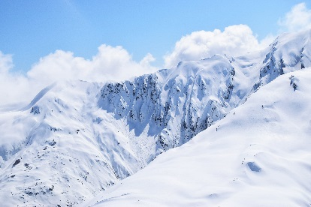 | 山区  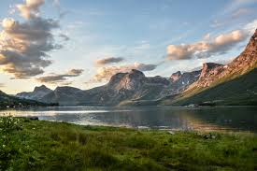 | 城市  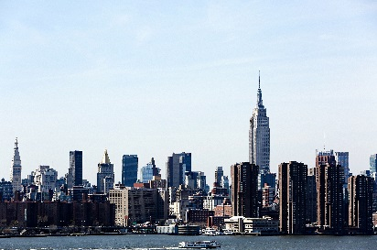

KEY

Ex.1) Types of holiday: 海滩, 山, 城市+旅行, …………

Holiday activities : 照相, 步行, 日光浴, 水上运动, 观光, 爬山,
滑雪, 下饭馆, 游泳, 购物+ diving, hiking ……..

Holiday adjectives: 放松的, 便宜, 刺激的+ boring, expensive , relaxing………..

Means of transport: 自行车, 船, 火车，邮轮+ on foot , car …….

Ex. 2) 1 c 2 b 3 b 4 c 5 a 6 b 7 c

