Colour Dictation

Dictation 1: Teacher to students

她的脸颊是粉色的。tā de liǎnjiá shì fěnsè de.
她的脸和手是橘黄色的。tā de liǎn hé shǒu shì jú huángsè de.
她穿着红裙子,她的衣领是绿色的。tā chuānzhuó hóng qúnzi tā de yīlǐng shì lǜsè de.
她上衣上的圆点也是绿色的。tā shàngyī shàng de yuán diǎn yěshì lǜsè de.
她的鞋是棕色的。tā de xié shì zōngsè de.

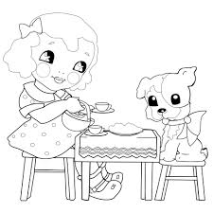

Dictation 2: student to student in pairs

Students create their own dictation about the little dog at the other side of the table. What colour is she? Her hair, her bow, her face etc.

