Colour Dictation

Dictation 1: Teacher to students

她的脸颊是粉色的。
她的脸和手是橘黄色的。
她穿着红裙子,她的衣领是绿色的。
她上衣上的圆点也是绿色的。
她的鞋是棕色的。

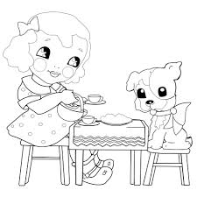

Dictation 2: student to student in pairs

Students create their own dictation about the little dog at the other side of the table. What colour is she? Her hair, her bow, her face etc.

