The Weather and Clothes

- READ THE PARAGRAPH AND COMPLETE THE SENTENCES:

Fan Bing住在北京。冬天很冷，下雪。她从不走着上学。她坐公共汽车。她戴帽子，手套，围巾，穿靴子。夏天很热，很晴朗。她穿凉鞋，T恤衫和短裤，她夏天不上学。现在是 春天，她穿T恤衫，牛仔裤和运动鞋。她现在花园里，她在浇花。

1- Fan Bing lives in Beijing.
2-What’s the weather in winter?.................................
3-What does she never do? ........................................
4-How does she go to work? .................
5-What does she wear in Winter?.....................
6-What’s Summer like?................................
7-What does she wear in Summer? ........................................
8- What doesn’t she do in Summer?.....................................
9-Where is she now? .............................................
10-What is she doing now? ...............................................

- WRITE THE NAME OF THE CLOTHES AND MATCH THEM WITH THE SEASONS YOU WEAR THEM.

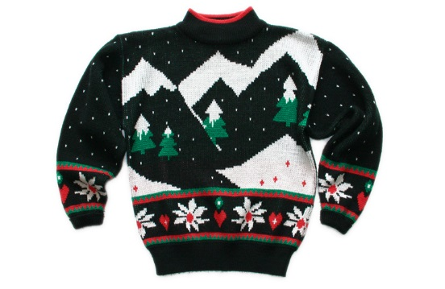  _______________ |  | 春天
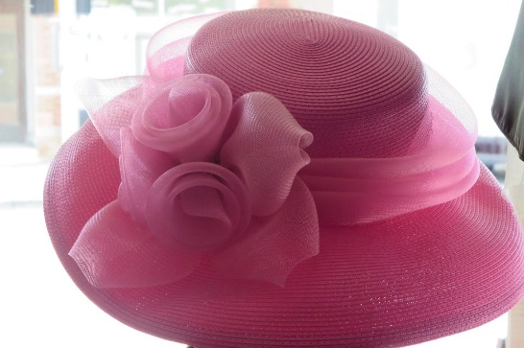

帽子

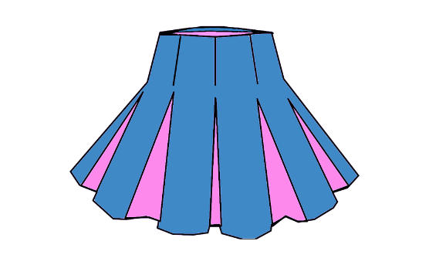  _______________ |  | 夏天
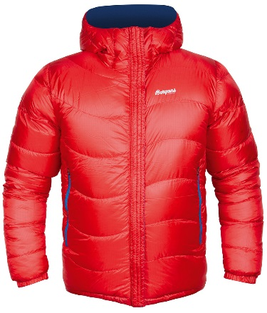

_______________

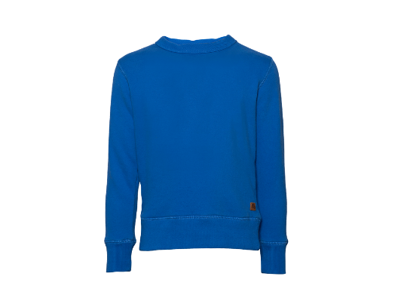  _______________ |  | 秋天

_______________

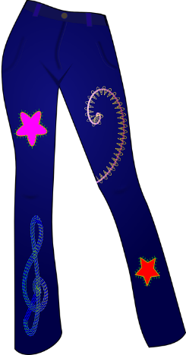  _______________ |  | 冬天




