度假明信片 Holiday Postcard

Lily and her sister Alice went on holiday to different places. They wrote postcards to their parents.
- Read Lily’s postcard. Is she happy with her holiday? Why?
亲爱的爸爸妈妈：  我现在在大连。我在这里很开心。这里的天气很好。天气很晴朗。我们有时在海滩上晒日光浴！午饭后，我们有时去潜水或者到超市买东西。这里的饭很好吃 – 鱼非常新鲜。我们住的饭店很新很干净。 这里的人很友好和善良。再见。  爱你们的  Lily | 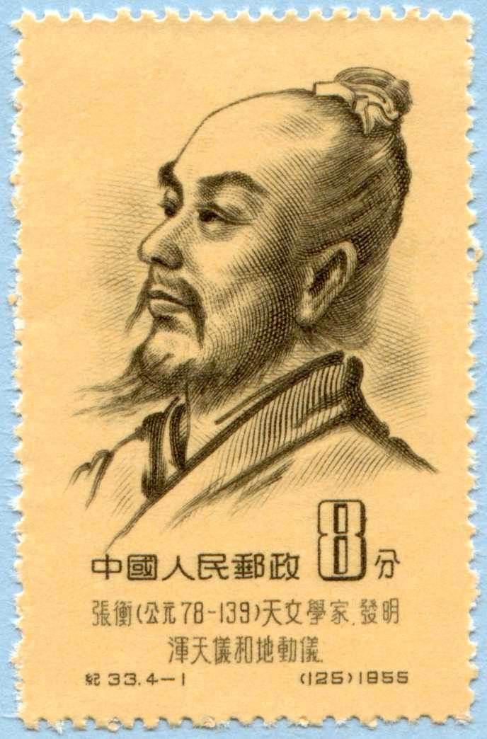  Marie and Chris Best  ___________________  48 Springfield Road  ___________________  London  ___________________  UK  ___________________

- Quite the contrary, Alice had a bad holiday. Everything went wrong. Please, help her write the postcard below.
- Replace the underlined words in Petra’s postcard with their opposites.
- Complete the dotted lines with your own words.
亲爱的爸爸妈妈：  我现在在……………..….….  我在这里很___________________ 。  这里的天气_______________________________.  我们有时…………….……! …..………..……后，我们有时……………………………….……. . .  这里的饭很_________________ – 很多 _______________ …………………… .  我们住的饭店____________________ 很_________________. 这里的人很_________________ 和________________________.  再见。爱你们的  Alice | Marie and Chris Best _____________  48 Springfield Road  _____________  London  _____________  UK  _____________

