Let’s Draw faces
Name: ________________
Date: ________________

Word Bank:
Body parts
眼睛yǎnjīng 嘴 zuǐ 鼻子bízi 下巴xiàbā
眉毛méi máo 脸颊 liǎnjiá 牙齿yáchǐ
舌头shétou 头发 tóufǎ 头tóu

How they look
高gāo 矮 ǎi 胖pàng 瘦shòu
漂亮piàoliang 好看hǎokàn 丑chǒu
长cháng 短duǎn 大dà 小xiǎo

- Draw and describe a “PUMPKIN face.

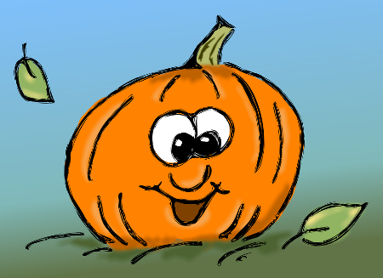
- Draw and describe an “APPLE face” and a “PUMPKIN face.

- Please help find the thief.
他很矮，很胖，tā hěn ǎi, hěn pàng,
鼻子很长，嘴巴很大。bízi hěn cháng, zuǐbā hěn dà.
他的耳朵很小，眼睛很圆。tā de ěrduo hěn xiǎo, yǎnjīng hěn yuán.
他是卷发，戴眼镜， tā shì juǎnfǎ, dài yǎnjìng,
嘴上有胡子。zuǐ shàng yǒu húzi.

What does he look like? Can you draw him?
WANTED

