Describing What’s in a Room

What are these room? What are the things in each room?
- Write down the names of the rooms
- Write down what you can find in each room.
- Extension: what else can be put in each room? Can you think of more words than your friends?

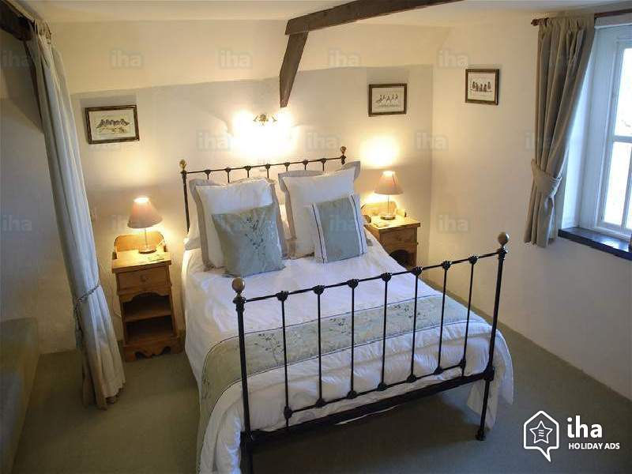 | 这是_______________  这里有：  ___________________  ___________________  ___________________  ___________________  ___________________  ___________________
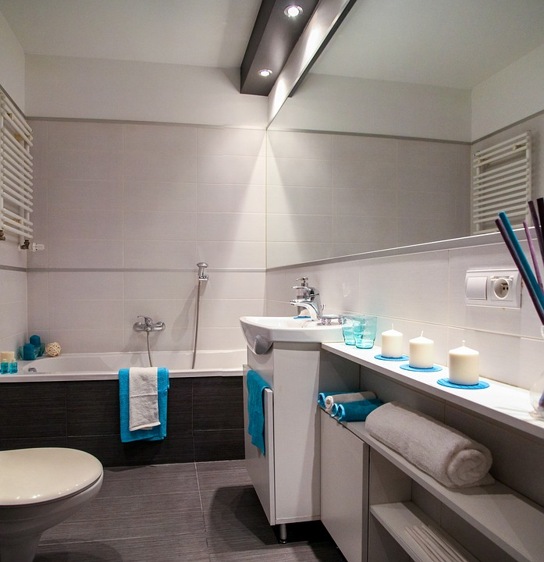 | 这是_______________  这里有：  ___________________  ___________________  ___________________  ___________________  ___________________  ___________________
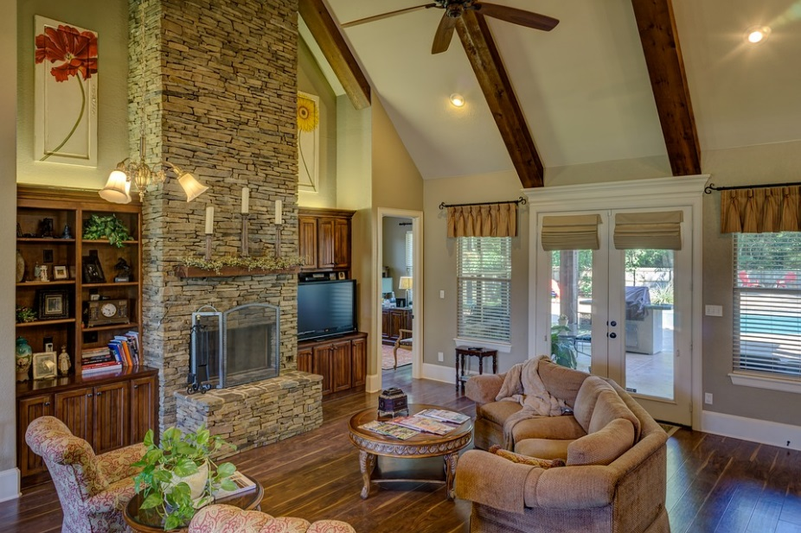 | 这是_______________  这里有：  ___________________  ___________________  ___________________  ___________________  ___________________  ___________________
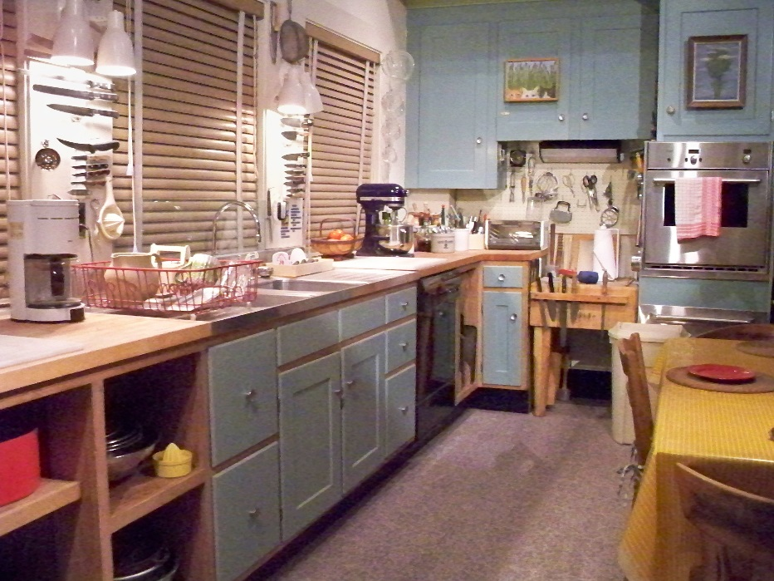 | 这是_______________  这里有：  ___________________  ___________________  ___________________  ___________________  ___________________  ___________________

Suggested answers: the students are not expected to write down all of them. But they are encouraged to identify at least 4-5 items in each room.

Bedroom
- Bed/ bunk bed  - Toys  - Pictures  - Posters  - Lamp  - Light  - Pillow  - Bed cover  - Duvet  - Dressing table  - Slippers  - Clothes  - wardrobe  - Desk | 1.床/双层床  2.玩具  3.图片  4.海报  5.灯  6.光  7.枕头  8.床罩  9.羽绒被  10.梳妆台  11.拖鞋  12.衣服  13.橱柜/衣柜  14桌子 | - chuáng/shuāng céng chuáng  - wánjù  - túpiàn  - hǎibào  - dēng  - guāng  - zhěntou  - chuángzhào  - yǔróng bèi  - shūzhuāng tái  - tuōxié  - yīfú  - chúguì/yīguì  - zhuōzi

Bathroom
- .Bath tub  - Shower  - Toilet  - Shower  - Soap  - Toilet tissue  - Shampoo  - Conditioner  - Body wash  - Toothbrush  - Toothpaste  - Lotion | 1.浴缸  2.淋浴  3.厕所  4.淋浴  5.肥皂  6.卫生纸  7.洗发水  8.空调  9.沐浴露  10.牙刷  11.牙膏  12.露 | - yùgāng  - línyù  - cèsuǒ  - línyù  - féizào  - wèishēngzhǐ  - xǐ fǎ shuǐ  - kòngtiáo  - mùyù lù  - yáshuā  - yágāo  - lù

Living room
- Sofa  - Cushion  - TV  - Stereo speakers  - Chairs  - Display cabinet  - Remote control | 1.沙发  2.靠垫  3.电视  4.立体声扬声器  5.椅子  6.显示柜  7.遥控器 | - shāfā  - kàodiàn  - diànshì  - lìtǐshēng  - yángshēngqì  - yǐzi  - xiǎnshì guì  - yáokòng qì

Kitchen
- Utensils (spoons, forks, etc.)  - Oven  - Stove  - Cupboards  - Fridge  - Freezer  - Dish washing machine  - Cups/glasses/mugs  - Bowls/dishes/saucers  - Flask, jugs, tea pots  - Food | 1.餐具（勺子，叉子等）  2.烤箱  3.火炉  4.橱柜  5.冰箱  6.冷冻  7. 洗碗机  8.杯/眼镜/杯子  9.碗/菜/碟  10.烧瓶，水壶，茶壶  11.食品 | - cānjù (sháozi, chāzi děng)  - kǎoxiāng  - huǒlú  - chúguì  - bīngxiāng  - lěngdòng  - xǐ wǎn jī  - bēi/yǎnjìng/bēizi  - wǎn/cài/dié  - shāopíng, shuǐhú, cháhú  - shípǐn

