**天气怎么样？**

**1. What do these weather icons mean?**

|  |  |  |
| --- | --- | --- |
| 2781175-zhou-zhuang-ancient-chinese-city-outside-of-shanghai-reflections-from-canals-on-a-sunny-day  **（1）**  **晴_________________** | 6625  **（2）**  **_________________** | http://www.esolers.org/ESOL/lowbeginner/vd/adj/cloudy.jpg  **（3）_________________** |
| images9  **（4）**  **_________________** | Chaim Soutine Windy Day in Auxerre oil painting picture  **（5）**  **_________________** | http://practiceyourenglish1.files.wordpress.com/2012/03/foggy-figure1.jpg  **（6）_________________** |
| [Image result for hot](https://www.google.co.uk/url?sa=i&rct=j&q=&esrc=s&source=images&cd=&cad=rja&uact=8&ved=0ahUKEwjut4DIve_VAhVC7RQKHWn3CEQQjRwIBw&url=https://pixabay.com/en/thermometer-temperature-hot-scale-153138/&psig=AFQjCNHoXYEV4g51NkOrwITbxjknLiZQ0w&ust=1503650697346137)  **（7）**  **_________________** | [Image result for cold temperature](https://www.google.co.uk/url?sa=i&rct=j&q=&esrc=s&source=images&cd=&cad=rja&uact=8&ved=0ahUKEwjrrKHuve_VAhXF1RQKHdfUBmEQjRwIBw&url=https://pixabay.com/en/temperature-thermometer-cold-winter-1300515/&psig=AFQjCNHZUCXdQ4nlnnmxd72Zt8BnKoRebA&ust=1503650788022468)  **（8）**  **_________________** | [Image result for rainbow](https://www.google.co.uk/url?sa=i&rct=j&q=&esrc=s&source=images&cd=&cad=rja&uact=8&ved=0ahUKEwjVytWKvu_VAhULvhQKHT7XCxIQjRwIBw&url=https://pixabay.com/en/rainbow-default-colors-948520/&psig=AFQjCNFrCWcw5Y_g-jh6cQp1msEMjdjnnA&ust=1503650848926896)  **（9）**  **_________________** |
| [Image result for ice](https://www.google.co.uk/url?sa=i&rct=j&q=&esrc=s&source=images&cd=&cad=rja&uact=8&ved=0ahUKEwiXxqa3vu_VAhUDuhQKHc6RDQ8QjRwIBw&url=https://commons.wikimedia.org/wiki/File:Ice_pic.jpg&psig=AFQjCNEPDNy9DF_DYPEyk1e7idK15SF2PQ&ust=1503650928052402)  **（10）**  **_________________** | [Image result for 闪电](https://www.google.co.uk/url?sa=i&rct=j&q=&esrc=s&source=images&cd=&cad=rja&uact=8&ved=0ahUKEwiM7PL5vu_VAhUFuRQKHT0KAv4QjRwIBw&url=https://pixabay.com/zh/%E9%9B%B7%E6%9A%B4-%E4%BA%91-%E9%97%AA%E7%94%B5-%E9%9B%A8-%E9%A3%8E%E6%9A%B4-%E5%A4%A9%E6%B0%94-154856/&psig=AFQjCNHG3fxV-1nnux_B6ZiWmWIyVFR1nQ&ust=1503651044941424)  **（11）**  **_________________** |  |

**2. Say what the weather is like in the following cities:**

|  |  |
| --- | --- |
| **cloudy  伦敦**  20C |  |
| **http://www.southafricanweather.co.za/aat/images/weather_icons_big/4.gif巴黎**  22C |  |
| **Пасмурно多伦多**  0 C |  |
| **[sun 144](http://www.wpclipart.com/weather/sun/sun_5/sun_144.png.html)北京**  33C |  |
| **overcast , heavy rain东京**  15C |  |

**3. Read the weather forecast and speak about the weather in your city:**

**今天上午北部地区很冷，有雨。午后，雨将转移到东部。**

**中部今天为多云。没有雨，但是天很阴。**

**南部为晴天或者多云，上午是晴天，午后转为多云。**

你的城市天气怎么样？

____________________________________________________________

____________________________________________________________

____________________________________________________________

____________________________________________________________

**4. 天气怎么样?**

|  |  |
| --- | --- |
| **K: Sam，你好! 北京的天气怎么样？**  **S: 你好, Kate! 北京天气非常热**  **K: 真的吗? 我好想去北京。**  **S: 是的，正像我想像的那样。很热很晴。**  **K: 气温是多少？**  **S: 38度。**  **K: 38度？开玩笑吧！**  **S: 没有，没开玩笑。真的。曼城很冷吗？**  **K: 很冷。气温很低。只有7度。**  **T: 哦，来北京吧！** |  |

**5. Arrange the conversation in logical order:**

|  |  |
| --- | --- |
| **-哦，别难过.**  **-不，不是. 是阴天.**  **-你在Brighton? 你在Brighton做什么?**  **-玩的开心吗?**  **-我在度假.**  **-你好, Jack. 我是Nick. 我现在在Brighton.**  **-不热，天气很冷。**  **-玩的不太开心. 今天天气太不好了.**  **-天气热吗?**  **- Brighton天气怎么样? 是晴天吗?** |  |

**Keys:**

**Ex.1**

**1–晴**

**2–雪**

**3–多云**

**4–雨**

**5–风**

**6–雾**

**7–热**

**8–冷**

**9–彩虹**

**10–冰**

**11–闪电**

**Ex.5**

**N: 你好, Jack. 我是Nick. 我现在在Brighton.**

**J: 你在Brighton? 你在Brighton做什么?**

**N: 我在度假.**

**J: Brighton天气怎么样? 是晴天吗?**

**N: 不，不是. 是阴天.**

**J: 天气热吗?**

**N: 不热，天气很冷。**

**J: 玩的开心吗?**

**N: 玩的不太开心. 今天天气太不好了.**

**J: 哦，别难过.**

[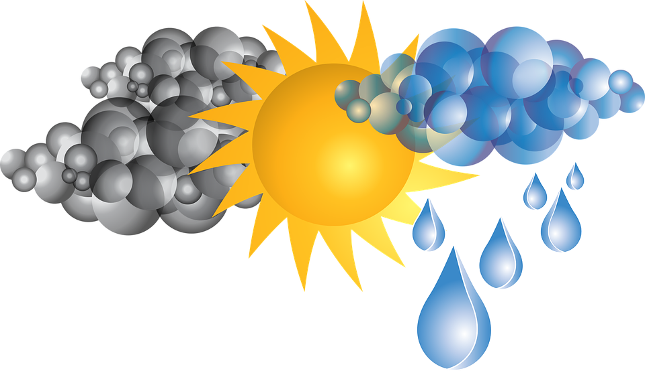](https://www.google.co.uk/url?sa=i&rct=j&q=&esrc=s&source=images&cd=&cad=rja&uact=8&ved=0ahUKEwjLkKr3w-_VAhUGuxQKHWaiC1AQjRwIBw&url=https://pixabay.com/en/clouds-rain-sun-weather-1293230/&psig=AFQjCNGPbsG6AtMPXVgrorj5fI4bqqEp-Q&ust=1503652339198670)