Your Last Holiday

1. [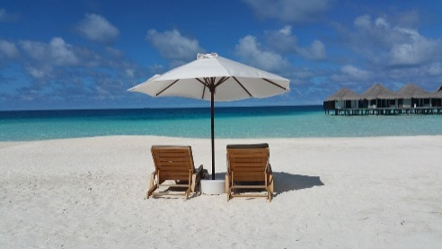](https://www.google.co.uk/url?sa=i&rct=j&q=&esrc=s&source=images&cd=&cad=rja&uact=8&ved=0ahUKEwjLtO_DgvDVAhVDRhQKHWwsAoYQjRwIBw&url=https://pixabay.com/en/maldives-holiday-beach-sun-summer-2312009/&psig=AFQjCNHLUz0041-vcrgiNfHjIHHGUCYtjQ&ust=1503669222434260)**Warm Up Work with a partner.**

Tell your partner about your last holiday. Say something about:

* 你们去了哪里？nǐmen qùle nǎlǐ
* 天气怎么样？tiānqì zěnme yàng?
* 你们做了什么？nǐmen zuòle shénme

1. **Vocabulary Match the verb to the activity.**

|  |
| --- |
| 参cān 观 guān 照 zhào 买 mǎi 去qù 写 xiě 观guān 坐 zuò  住 zhù 吃chī |
| _____相 xiāng _____光 guāng _____纪念品jìniànpǐn  _____飞机 fēijī _____饭店 fàndiàn _____购物gòuwù  _____饭 fàn _____画廊huàláng _____明信míngxìnpiàn |

_____ _____

1. **Read the conversation and fill in the missing words.**

Tom: Julie, 你去哪里度假了？Julie, nǐ qù nǎlǐ dùjiàle

Julie：我去三亚度假了。wǒ qù sānyà dùjiàle

Tom:真的？怎么样？zhēn de? Zěnme yàng

Julie：非常好fēicháng hǎo！海滩hǎitān ___________。天气也很好。tiānqì yě hěn hǎo

Tom:你住了nǐ zhùle ___________时间shíjiān？

Julie：我住了十天。wǒ zhùle shí tiān

Tom:你在里做什么？nǐ zài lǐ zuò shénme

Julie：我晒wǒ shài ___________，还吃了hái chīle ___________。

[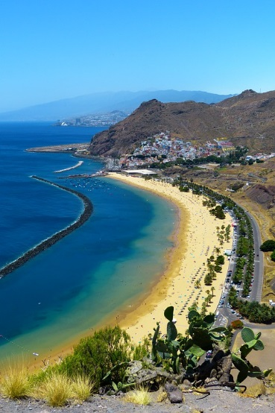](http://www.google.co.uk/url?sa=i&rct=j&q=&esrc=s&source=images&cd=&cad=rja&uact=8&ved=0ahUKEwjt56CfhvDVAhVFbhQKHQQpB68QjRwIBw&url=http://maxpixel.freegreatpicture.com/Canary-Islands-Holiday-Tenerife-Landscape-Beach-2307670&psig=AFQjCNHLUz0041-vcrgiNfHjIHHGUCYtjQ&ust=1503669222434260)

Missing words:

|  |
| --- |
| 日光浴 rìguāngyù 漂亮极了 piàoliang jíle  美食měishí 多长duō zhang |

1. **Write answers to these questions.**
2. Julie去哪里度假了？Julie qù nǎlǐ dùjiàle
3. 哪里的海滩怎么样？nǎlǐ dì hǎitān zěnme yàng
4. 她住了多长时间？tā zhùle duō cháng shíjiān
5. 她在哪里做了什么？tā zài nǎlǐ zuòle shénme
6. **Question Practice How well do you remember? Write the questions in the blanks.**

Tom: Julie, ___________度假了dùjiàle？

Julie：我去三亚度假了。Wǒ qù sānyà dùjiàle

Tom:真的Zhēn de？___________？

Julie：非常好fēicháng hǎo！海滩漂亮极了hǎitān piàoliang jíle。天气也很好tiānqì yě hěn hǎo!

Tom: ___________？

Julie：我住了十天。wǒ zhùle shí tiān

Tom: ___________？

Julie：我晒日光浴 ，还吃了美食 。wǒ shài rìguāngyù, hái chīle měishí

**6. Look at the pictures below. Which countries do they show?**

[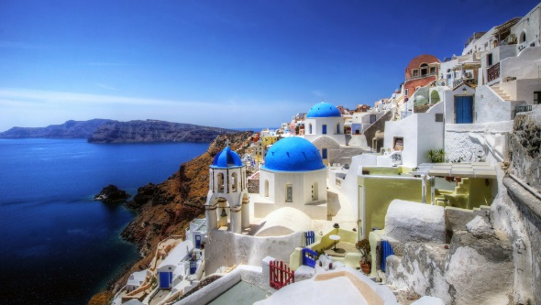](https://www.google.co.uk/url?sa=i&rct=j&q=&esrc=s&source=images&cd=&cad=rja&uact=8&ved=0ahUKEwjPzfuciPDVAhWLuhQKHS5kAEUQjRwIBw&url=https://www.flickr.com/photos/39997856@N03/10920944764&psig=AFQjCNFfMyRVivGkTgMJNnBSPoaxXO1z9w&ust=1503670755969856)1）___________________

[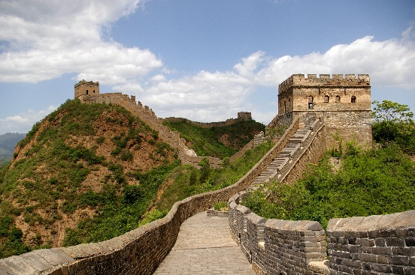](https://www.google.co.uk/url?sa=i&rct=j&q=&esrc=s&source=images&cd=&cad=rja&uact=8&ved=0ahUKEwj8l877h_DVAhWBRhQKHVTIBRkQjRwIBw&url=https://commons.wikimedia.org/wiki/File:20090529_Great_Wall_8125.jpg&psig=AFQjCNH-sydcEYovo_XKmol1GD8jzIYFtw&ust=1503670669752275)2）___________________

[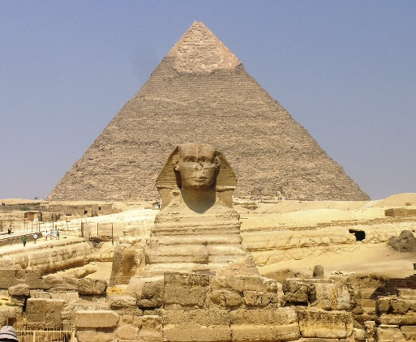](https://www.google.co.uk/url?sa=i&rct=j&q=&esrc=s&source=images&cd=&cad=rja&uact=8&ved=0ahUKEwixqJXXh_DVAhWBWBQKHe0LC8UQjRwIBw&url=https://commons.wikimedia.org/wiki/File:Giza_Plateau_-_Great_Sphinx_with_Pyramid_of_Khafre_in_background.JPG&psig=AFQjCNFXrNp-bb3tbkct7LQiSYHMP970hw&ust=1503670604063993)3）___________________

[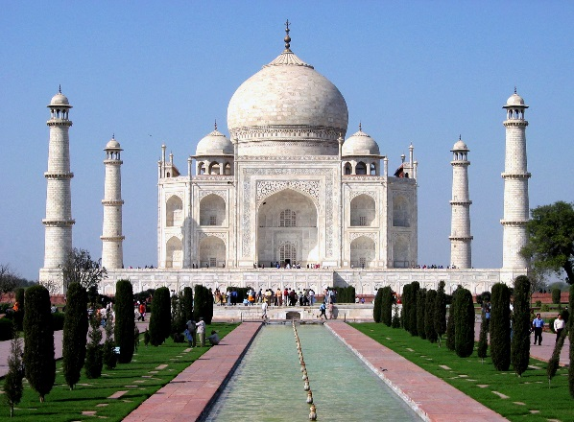](https://www.google.co.uk/url?sa=i&rct=j&q=&esrc=s&source=images&cd=&cad=rja&uact=8&ved=0ahUKEwjBnOm4iPDVAhWLPBQKHY7-Cp8QjRwIBw&url=https://en.wikipedia.org/wiki/Taj_Mahal&psig=AFQjCNGzaoKv0PLIc9QzXC-YAZE1zvhtJg&ust=1503670811615225)4）___________________

*谁 *

*什么时候*

*怎么样 在哪里*

*为什么 做什么*

Imagine you went to these places on holiday. Have conversations with a partner.

Use your imagination, or vocabulary from exercise two.

Use ideas words from the box to help you.

Try to ask follow-up questions.

1. **Discussion Work with a partner, or in small groups. Ask follow-up questions.**

* What was your best holiday? Why did you like it?
* Which do you like more: foreign or domestic holidays?
* Do you take photographs or make home videos when on holiday?
* Which places are popular in your country with foreign tourists?

Answer key (Other answers may be possible.)

2．

照相 观光 买纪念品

坐飞机 住饭店 去购物

吃饭 参观画廊 写明信片

3

1) 漂亮极了

2) 多长

3) 日光浴

4) 美食

4．

1) 她去了三亚。

2) 很漂亮

3) 她住了十天

4) 她晒了日光浴，吃了美食。

6．

1) 希腊Greece (Santorini)

2) 中国China (The Great Wall of China)

3) 埃及Egypt (the Pyramids)

4) 印度India (The Taj Mahal)