***MEANS OF TRANSPORT – PICTIONARY***

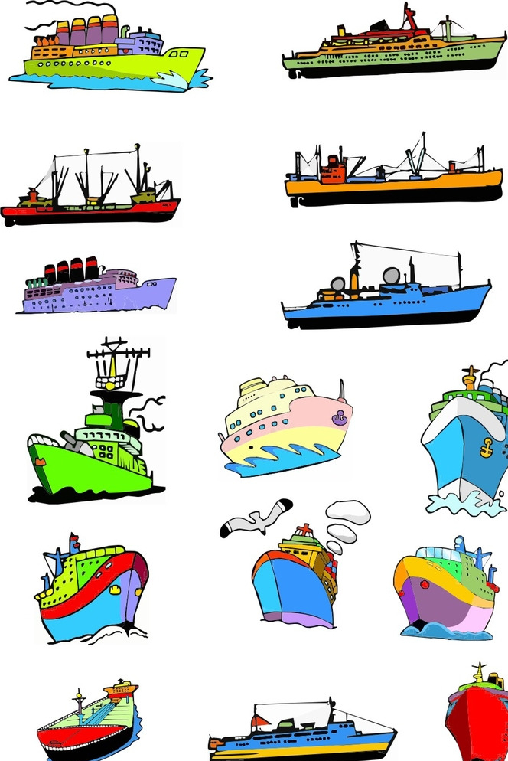 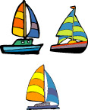 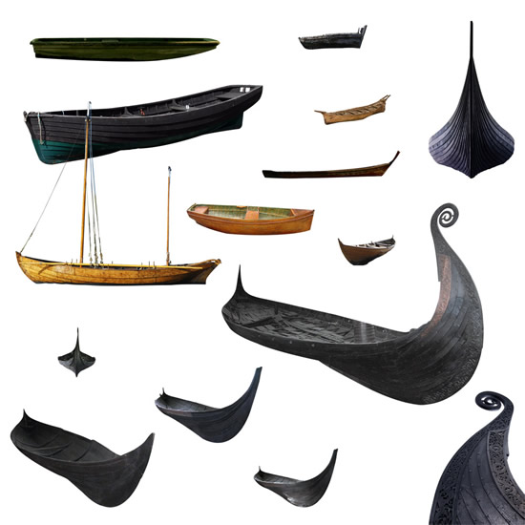

轮 船 lúnchuán 帆 船 fānchuán 独木舟 dúmùzhōu

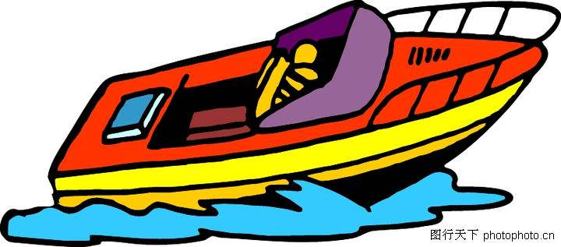 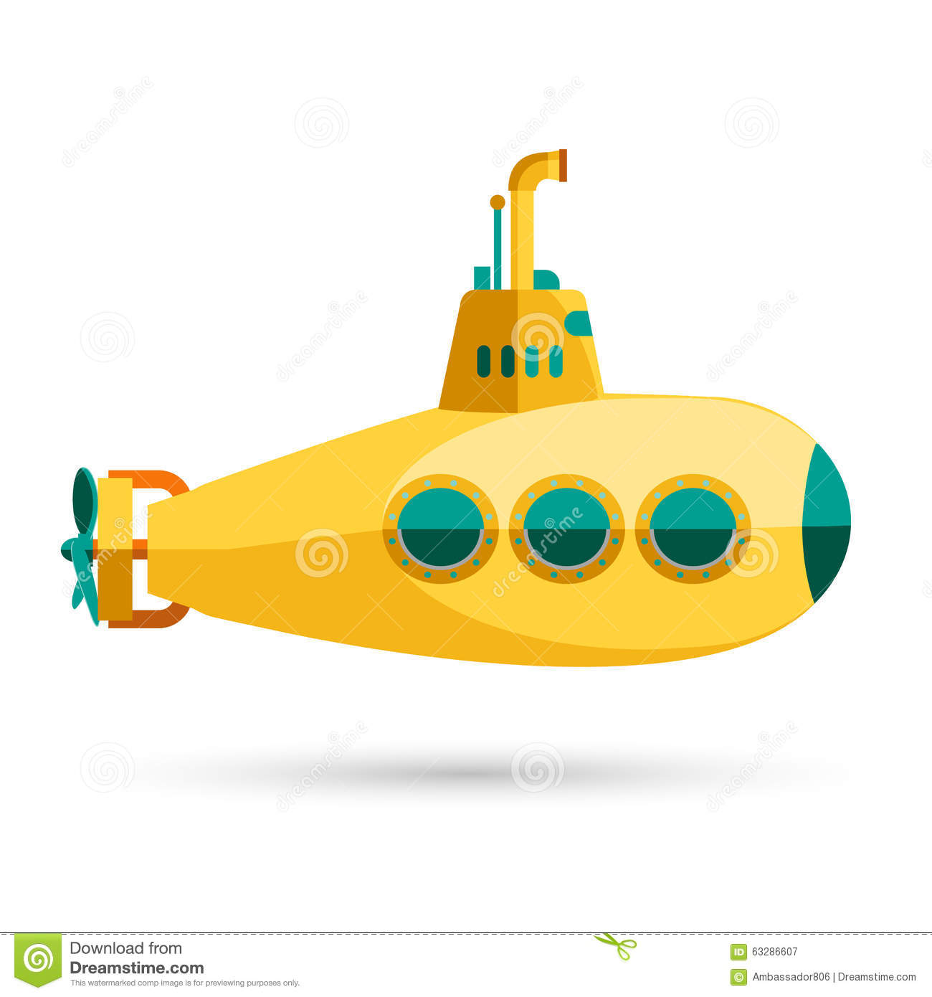 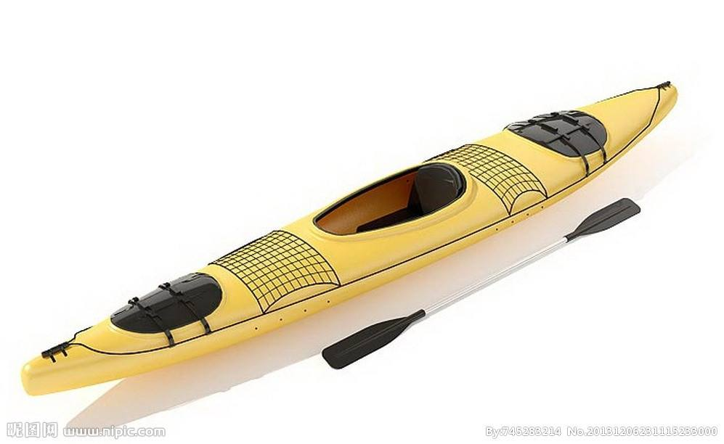

快 艇 kuàitǐng 潜水艇qiǎnshuǐtǐng 皮划艇 píhuátǐng

[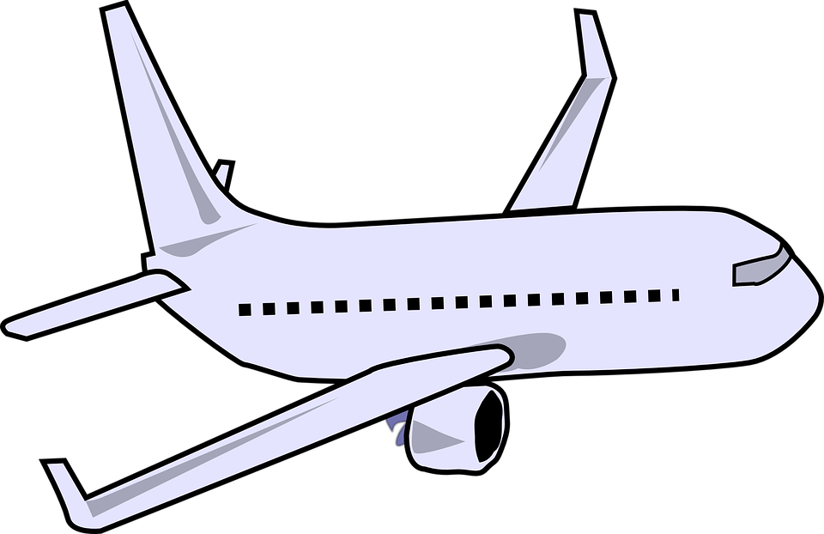](https://www.google.co.uk/url?sa=i&rct=j&q=&esrc=s&source=images&cd=&cad=rja&uact=8&ved=0ahUKEwj1xIWHhvPWAhWRmbQKHZfgCi8QjRwIBw&url=https://pixabay.com/en/photos/commercial%20jet/&psig=AOvVaw0KlaqgJHvMOl1Op-0xQsb9&ust=1508171285328441) 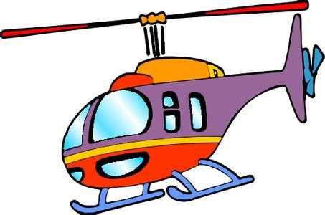 [](https://www.google.co.uk/url?sa=i&rct=j&q=&esrc=s&source=images&cd=&cad=rja&uact=8&ved=0ahUKEwjHwY3rivPWAhUMfFAKHT5yCVUQjRwIBw&url=https://pixabay.com/en/balloon-hot-transportation-fly-air-24361/&psig=AOvVaw2I-os8TEJBwoj8QFA_-Cjm&ust=1508172552655832)

飞 机 fēijī 直升飞机 zhíshēngfēijī 热气球 rèqìqiú

[](http://www.google.co.uk/url?sa=i&rct=j&q=&esrc=s&source=images&cd=&cad=rja&uact=8&ved=0ahUKEwjgqsiVi_PWAhXREVAKHawID0EQjRwIBw&url=http://www.freestockphotos.biz/stockphoto/16613&psig=AOvVaw1xuTbKruR6c9EP_jBLLhGW&ust=1508172662469087)  

火 箭 huǒjiàn 降落伞 jiàngluòsǎn 飞 碟 fēidié

BY SEA

Contributed by Zhou Hong ， King Edward VII Academy

BY AIR

[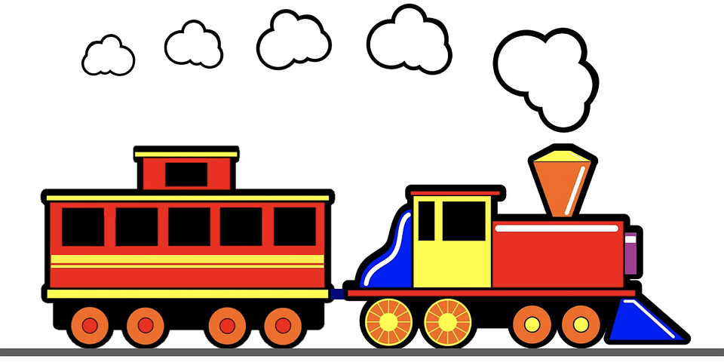](https://www.google.co.uk/url?sa=i&rct=j&q=&esrc=s&source=images&cd=&cad=rja&uact=8&ved=0ahUKEwi3wPq_sfPWAhWCZFAKHe3VC0UQjRwIBw&url=https://pixabay.com/en/train-steam-rail-railway-railroad-2582669/&psig=AOvVaw0CHjWmEL1BvHl5xTkeJHw0&ust=1508182935731910) [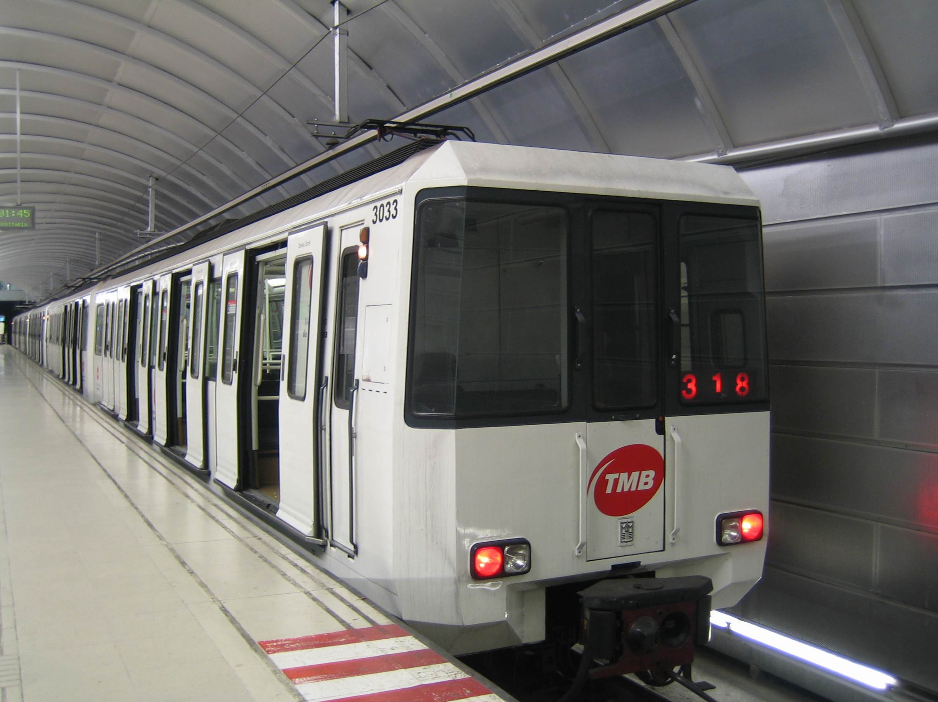](https://www.google.co.uk/url?sa=i&rct=j&q=&esrc=s&source=images&cd=&ved=0ahUKEwin56vtt_PWAhUBLlAKHfoBDUQQjRwIBw&url=https://en.wikipedia.org/wiki/Barcelona_Metro&psig=AOvVaw1ypzAYSnSIOA2OgoE7Umcp&ust=1508184649510772) [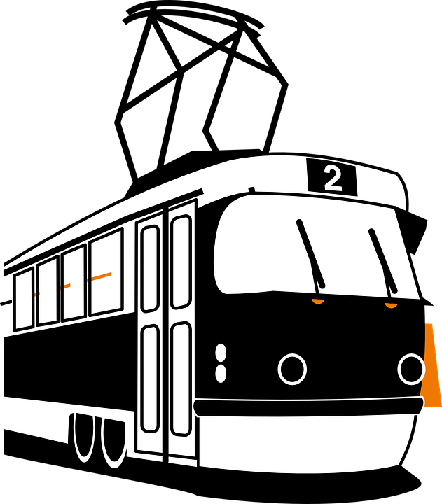](https://www.google.co.uk/url?sa=i&rct=j&q=&esrc=s&source=images&cd=&cad=rja&uact=8&ved=0ahUKEwjlrZyTufPWAhWOLlAKHVk_D0IQjRwIBw&url=https://pixabay.com/en/tram-engine-electric-transportation-312371/&psig=AOvVaw2Cy3TLcX1WyxVPW99GjTLd&ust=1508185003936198)

火 车 huǒchē 地 铁 dìtiě 电 车 diànchē

BY RAIL

[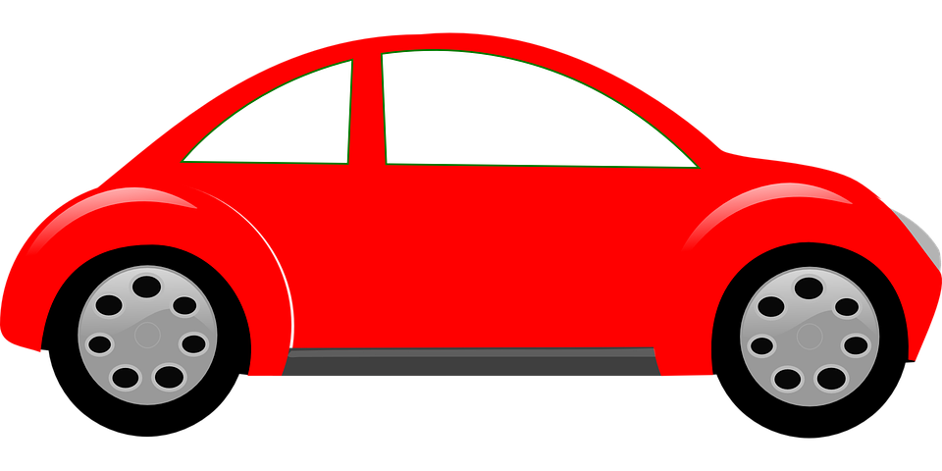](https://www.google.co.uk/url?sa=i&rct=j&q=&esrc=s&source=images&cd=&cad=rja&uact=8&ved=0ahUKEwjAmoDIqfPWAhUPLlAKHXOLC0sQjRwIBw&url=https://pixabay.com/en/photos/red%20car/?image_type%3Dillustration&psig=AOvVaw3UH1FxIv0FINlPgk-wSQAO&ust=1508180787144704) [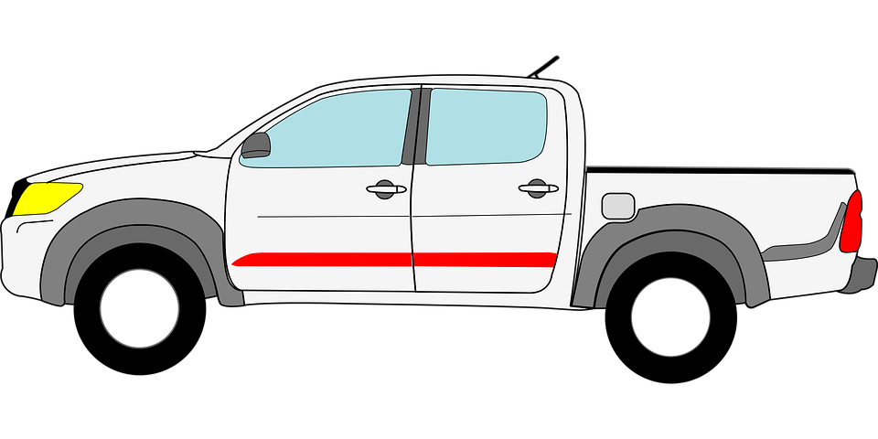](https://www.google.co.uk/url?sa=i&rct=j&q=&esrc=s&source=images&cd=&cad=rja&uact=8&ved=0ahUKEwjKuoafqvPWAhVFuxQKHdrdA8YQjRwIBw&url=https://pixabay.com/en/photos/pickup%20truck/&psig=AOvVaw1dcTf8-rdW9z5SMOSZlPW1&ust=1508181003854810) [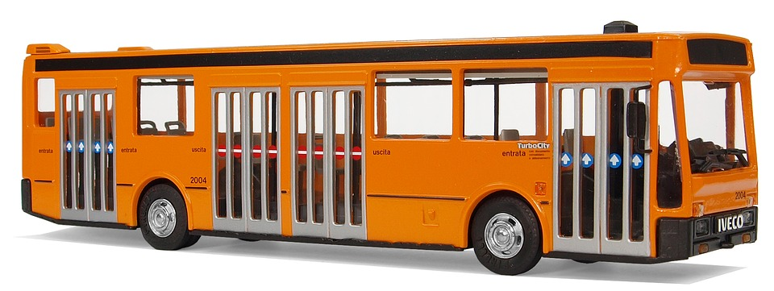](https://www.google.co.uk/url?sa=i&rct=j&q=&esrc=s&source=images&cd=&cad=rja&uact=8&ved=0ahUKEwj4z5-8q_PWAhUDIVAKHS-UAEMQjRwIBw&url=https://pixabay.com/en/photos/city%20bus/&psig=AOvVaw3NvB0aAktCx0lb7Vnf7w-m&ust=1508181321972509)

汽 车 qìchē 卡 车 kǎchē 公共汽车 gōnggòngqìchē

[](https://www.google.co.uk/url?sa=i&rct=j&q=&esrc=s&source=images&cd=&cad=rja&uact=8&ved=0ahUKEwj19LClrPPWAhVOL1AKHdpICzUQjRwIBw&url=https://pixabay.com/en/photos/police/?image_type%3Dvector&psig=AOvVaw0sJmirHrWOZ0bICzmrUVCX&ust=1508181522319713) [](https://www.google.co.uk/url?sa=i&rct=j&q=&esrc=s&source=images&cd=&cad=rja&uact=8&ved=0ahUKEwjjqPufrfPWAhWRLlAKHQMdDkUQjRwIBw&url=https://pixabay.com/en/car-ambulance-medical-sick-160292/&psig=AOvVaw1xMLZwya2dBoawGBy4R0hM&ust=1508181795724315) [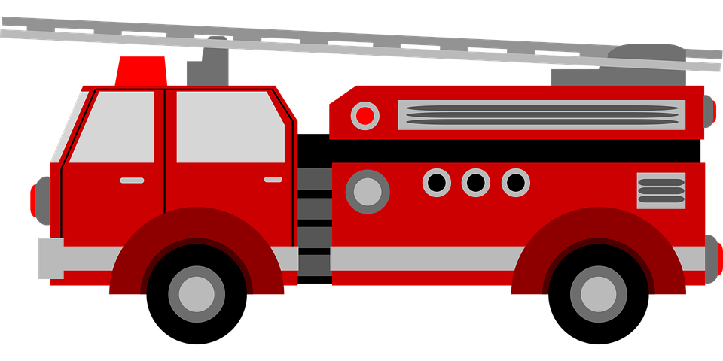](https://www.google.co.uk/url?sa=i&rct=j&q=&esrc=s&source=images&cd=&cad=rja&uact=8&ved=0ahUKEwj3rc7GrfPWAhUNYlAKHXbtCC8QjRwIBw&url=https://pixabay.com/en/photos/fireman/&psig=AOvVaw1mx3bjjmK2bwwnh2wLhsXd&ust=1508181893100492)

警 车 jǐngchē 救护车 jiùhùchē 救火车 jiùhuǒchē

[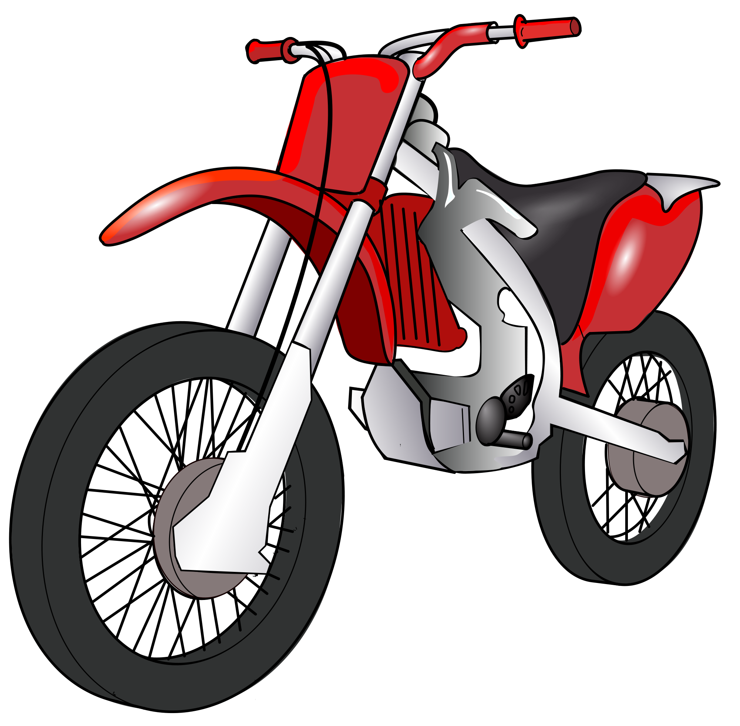](https://www.google.co.uk/url?sa=i&rct=j&q=&esrc=s&source=images&cd=&cad=rja&uact=8&ved=0ahUKEwi7wc63rvPWAhVIZFAKHbrZA0sQjRwIBw&url=https://commons.wikimedia.org/wiki/File:Motorbike.svg&psig=AOvVaw0a9jfzUr8NDlFp2FEpJPp4&ust=1508182123877281) [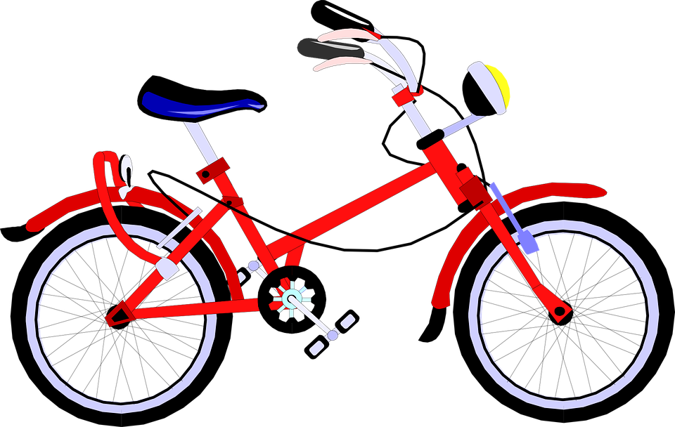](https://www.google.co.uk/url?sa=i&rct=j&q=&esrc=s&source=images&cd=&cad=rja&uact=8&ved=0ahUKEwjJnZLqrvPWAhWDIlAKHTIxCkcQjRwIBw&url=https://pixabay.com/en/bike-bicycle-wheels-sport-160096/&psig=AOvVaw0gGes4lSWi1jACGUq7L0Tc&ust=1508182201665375) [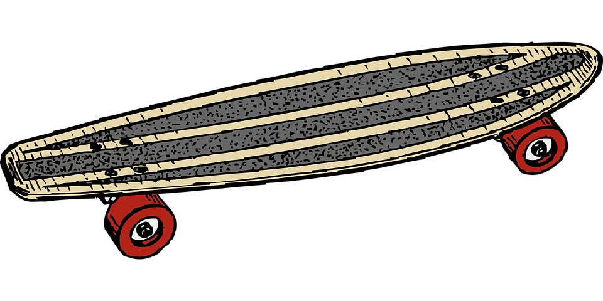](https://www.google.co.uk/url?sa=i&rct=j&q=&esrc=s&source=images&cd=&cad=rja&uact=8&ved=0ahUKEwiezsi8r_PWAhUHZlAKHSMrBzAQjRwIBw&url=https://pixabay.com/en/skateboard-board-wheeled-slide-29194/&psig=AOvVaw0LcEMe6fulxpDKAeyiBxBP&ust=1508182376765608)

摩托车 mótuóchē 自行车 zìxíngchē 滑板 huábǎn

BY LAND

***MEANS OF TRANSPORT – PICTIONARY***

Contributed by Zhou Hong ， King Edward VII Academy

*MEANS OF TRANSPORT - PICTIONARY*