Instruction:
Instruction:
This material contains three activities.
本材料包括三个练习。
Activity 1: This is the matching game. Students (can be in pairs or groups of 3/4) take it in turns to match an activity and a place.
练习1：是配对游戏，学生需轮流进行。每轮选择页面右侧一个活动，匹配左侧相应的活动地点。

Activity 2: Below (p.5 and p.6) there are templates for dice with place images of them. This is a speaking and writing activity. Players roll the dice, when you get a new place, say it out loud and write it down in Chinese.
练习2：是掷骰子游戏。每获得一个新地点，需大声说出来并写下该地点的中文单词。

Activity 3: This activity is a mix of the two
3.1: Use the dice on page 5 and/or 6 to complete this activity. Roll the dice, and see if you can find it on the map (p.8). Tick it and read out loud if you can. Try again for next rolls until you complete all the places on the map.
3.2 (extension): Make a short paragraph to talk where you have gone and what is your route, then why you go there.
For example（例如）：首先，我去了+place，因为+activity；然后，我去了+place，因为+activity。接着，我去了place A，place A在 Place B旁边；最后，我去了place C，Place C在Place D 左边/前边……

练习3：是一个综合练习。学生从练习1中已经获得了一定数量的活动及对应地点；用练习2的骰子抛色子，抛到自己拥有的任一地点，可以在地图相应位置做标记，抛到其他地点，只需说出这一地点的中文单词。首先在地图上标记完手中所有地点的学生获胜。
最后，学有余力的学生，还可以根据自己标记的地点顺序及相应活动说一小段话。
For example（例如）：首先，我去了+place，因为+activity；然后，我去了+place，因为+activity。接着，我去了place A，place A在 Place B旁边；最后，我去了place C，Place C在Place D 左边/前边……

KEY:
Page 3
一、E 二、A 三、B 四、F 五、D 六、C

Page 4
七、J 八、G 九、L 十、H 十一、I 十二、
Activity 1
Where do these people want to go? Match the activities to the places:
A. My friends usually see good films there.
一. 火车站 huǒchēzhàn

B. I exercise there three times a week.
二. 电影院 diànyǐngyuàn

C. Where I can get some apples and some tomatoes.
三. 运动中心 yùndòng zhōngxīn
D. Where I usually borrow books after school.
四. 公园 gōngyuán
五. 图书馆 túshūguǎn
E. I usually go to London by train.

F. Where I like to walk with my dog.
六 商店 shāngdiàn

Aim higher.
Where do these people want to go? Match the activities to the places:
G. I’ve got a terrible headache.
七. xuéxiào 学校 School

H. I need some cash to pay the bill.
八. yīyuàn 医院 Hospital

I. My family having dinner out to celebrate my parent’s wedding ceremony.
九. yóujú 邮局 Post Office
十. yínháng 银行 Bank

J. Students go there from Monday to Friday.

十一. fàndiàn 饭店 Restaurant
K. I lost my phone on the street.
十二. jǐngchájú 警察局
Police Station
L. I want to send a Christmas card to my best friend.
Activity2:
Die 1 for Page 3
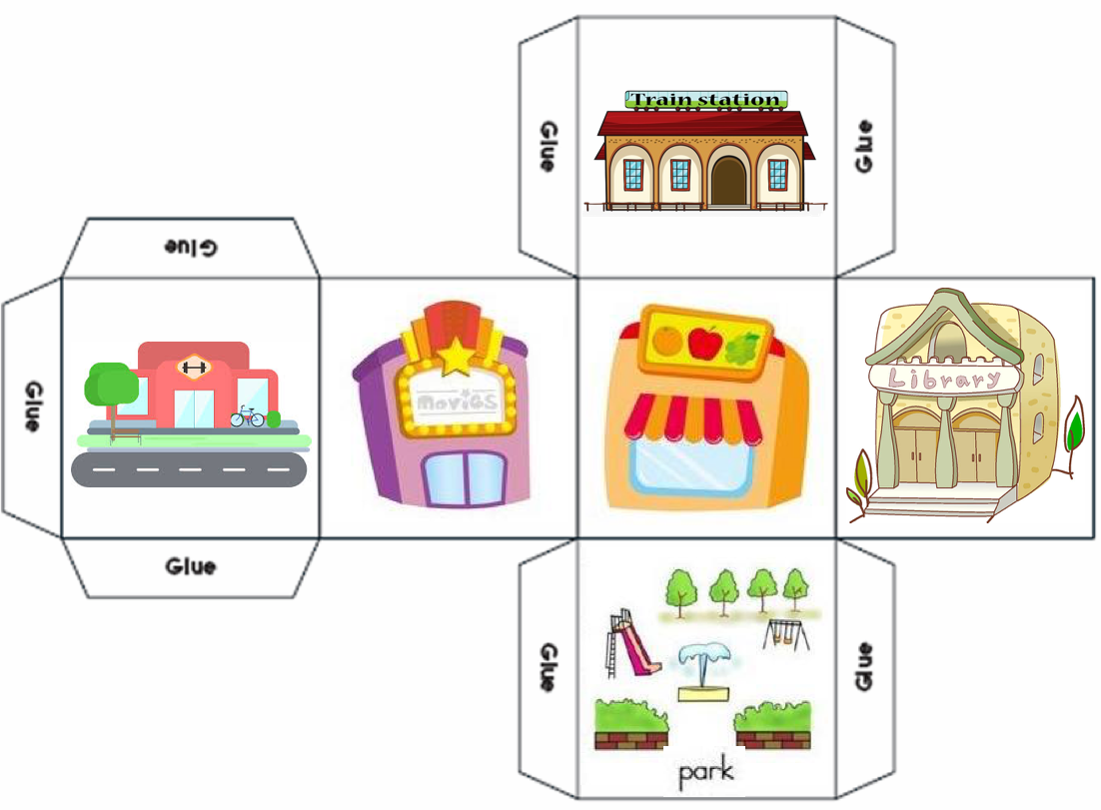
Die 2 for Page 4:
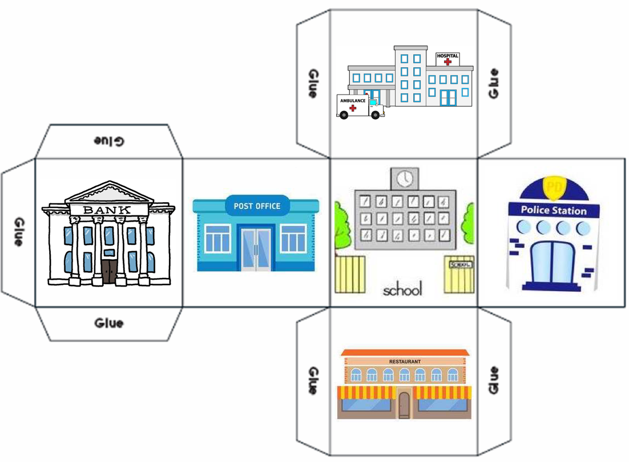

Activity 2. Writing paper:
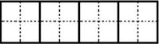
Train Station School

Cinema Hospital

Sports Center Post Office

Park Bank

Library Restaurant

Store Police Station

Activity 3
Challenge：

