2

**Where shall we meet？**

B. True ( T ) or false ( F ):

|  |  |  |
| --- | --- | --- |
|  | 1. 网球在熊猫的左边。 wǎngqiú zài xióngmāo de zuǒbiān | F |
|  | 2. 橄榄球在熊猫的后边。gǎnlǎnqiú zài xióngmāo de hòubian |  |
|  | 3. 篮球在熊猫的右边。lánqiú zài xióngmāo de yòubiān |  |
| [“足球”的图片搜索结果](http://www.google.com.hk/url?sa=i&rct=j&q=&esrc=s&source=images&cd=&cad=rja&uact=8&ved=0ahUKEwjopqO56PjXAhXpBsAKHYi1DioQjRwIBw&url=http://www.publicdomainpictures.net/view-image.php?image%3D144619%26picture%3D%26jazyk%3DCN&psig=AOvVaw15kgRtGvfUJi4lw8Wz7np5&ust=1512767319687019) | 4. 足球在熊猫的前边。zúqiú zài xióngmāo de qiánbian |  |

A. Label the right direction.

a.前qián b.后hòu c.左 zuǒ d.右yòu

[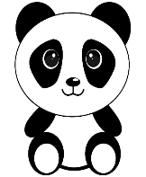](https://www.google.com/url?sa=i&rct=j&q=&esrc=s&source=images&cd=&cad=rja&uact=8&ved=0ahUKEwiJ3ryyrPDXAhWEJ8AKHddeBhoQjRwIBw&url=https://pixabay.com/users/1426978/&psig=AOvVaw3XPHqgcp51Zz93os0quDrE&ust=1512476458785364)

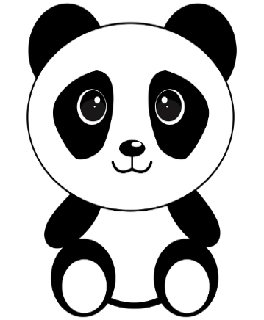

1. left

**C**

2. right _________

3. back ______

4. front _______

[](https://www.google.com/url?sa=i&rct=j&q=&esrc=s&source=images&cd=&cad=rja&uact=8&ved=0ahUKEwji87ORrvDXAhULKcAKHQzxBiAQjRwIBw&url=https://pixabay.com/en/photos/tennis/?image_type%3Dillustration&psig=AOvVaw3vpKsH_WOZLdkg1QwNXK30&ust=1512477022153775)

[](https://www.google.com/url?sa=i&rct=j&q=&esrc=s&source=images&cd=&cad=rja&uact=8&ved=0ahUKEwiJ3ryyrPDXAhWEJ8AKHddeBhoQjRwIBw&url=https://pixabay.com/users/1426978/&psig=AOvVaw3XPHqgcp51Zz93os0quDrE&ust=1512476458785364)

[](https://www.google.com.hk/url?sa=i&rct=j&q=&esrc=s&source=images&cd=&cad=rja&uact=8&ved=0ahUKEwir-Yvq6vjXAhWFbVAKHYWlB6gQjRwIBw&url=https://en.wikipedia.org/wiki/Gridiron_football&psig=AOvVaw2sgmGGrN-hVyhnX4AXxMkv&ust=1512768189887576)

[](https://www.google.com/url?sa=i&rct=j&q=&esrc=s&source=images&cd=&cad=rja&uact=8&ved=0ahUKEwiJ3ryyrPDXAhWEJ8AKHddeBhoQjRwIBw&url=https://pixabay.com/users/1426978/&psig=AOvVaw3XPHqgcp51Zz93os0quDrE&ust=1512476458785364)

[](https://www.google.com.hk/url?sa=i&rct=j&q=&esrc=s&source=images&cd=&cad=rja&uact=8&ved=0ahUKEwiXoeCC5_jXAhWMIsAKHeAMACwQjRwIBw&url=https://pixabay.com/zh/%E7%AF%AE%E7%90%83-%E8%BF%90%E5%8A%A8-%E6%A9%99%E8%89%B2-%E5%8F%8D%E6%80%9D-306812/&psig=AOvVaw2yXbtZToprAAWrmwKkVvxG&ust=1512767155690334)

[](https://www.google.com/url?sa=i&rct=j&q=&esrc=s&source=images&cd=&cad=rja&uact=8&ved=0ahUKEwiJ3ryyrPDXAhWEJ8AKHddeBhoQjRwIBw&url=https://pixabay.com/users/1426978/&psig=AOvVaw3XPHqgcp51Zz93os0quDrE&ust=1512476458785364)

1. 大中的汽车是绿色的。 在他的右边也是

一辆绿色的汽车。但是大中前面的汽车是

橙色的， 后面的汽车是蓝色的。

Dàzhōng de qìchē shì lǜsè de. zài tā de yòubiān yěshì

yī liàng lǜsè de qìchē. dànshì Dàzhōng qiánmiàn de

qìchē shì chéngsè de, hòumiàn de qìchē shì lán sè de.

Q：大中的汽车是哪一辆 ？________

Dàzhōng de qìchē shì nǎ yī liàng ?

C. Read and answer questions:

c

b

a

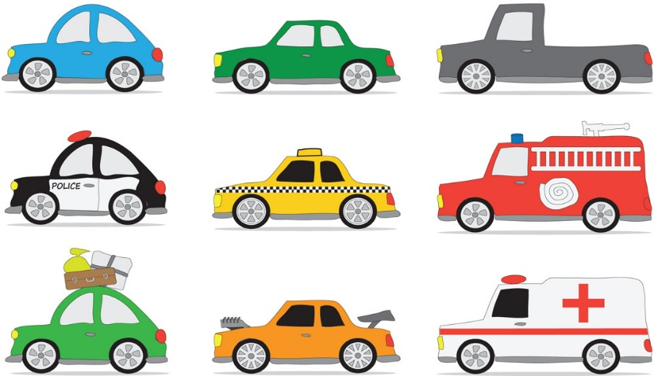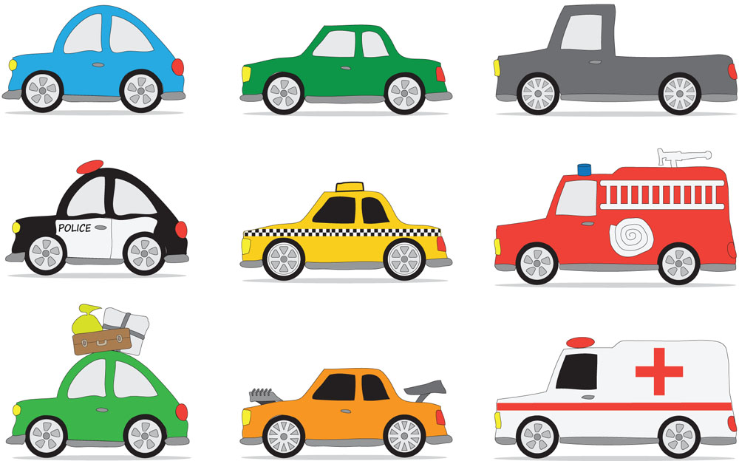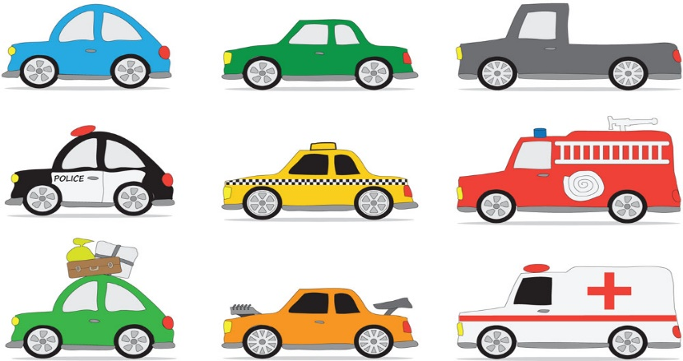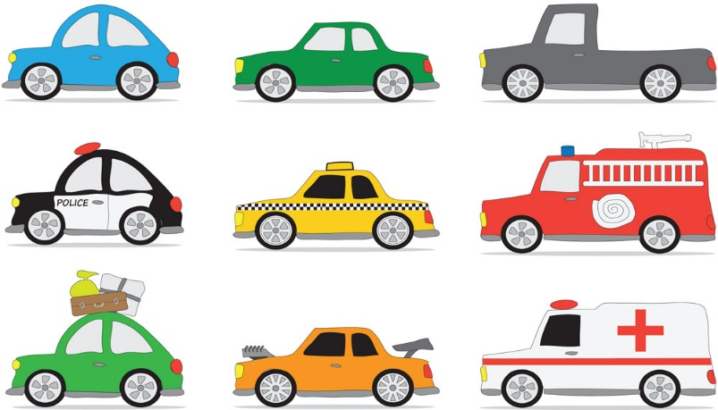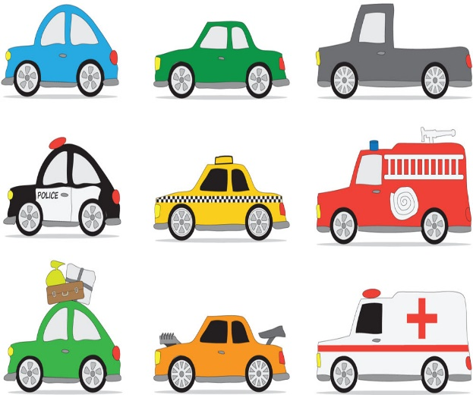

d

e

f

d

c

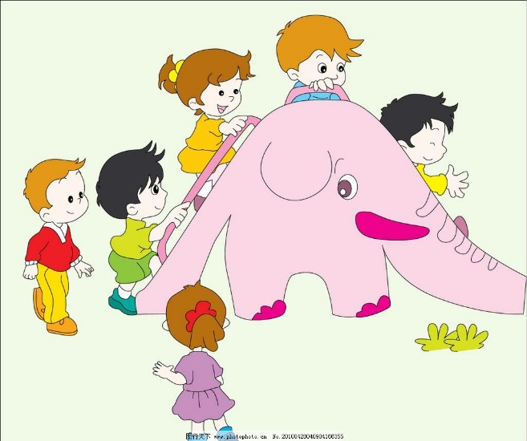

2. 大家好。我叫小龙。我有黄色的头发，

我穿着蓝色的T恤衫。 我前面是一个黑色

头发的男孩， 我后面是穿黄色裙子的女孩。

dàjiā hǎo. wǒ jiào Xiǎolóng. wǒ yǒu huángsè de tóufǎ,

wǒ chuānzhuó lán sè de T xùshān. wǒ qiánmiàn shì yīgè hēisè tóufǎ de nánhái, wǒ hòumiàn shì chuān huángsè qúnzi de nǚhái.

Q：小龙是哪一个小朋友？ ___________

Xiǎolóng shì nǎ yīgè xiǎopéngyǒu？

e

a

b

Contributed by Zhou Hong ， King Edward VII Academy

Answers to activities:

This activity is meant to help the students to practice the four directions. By looking at the pictures and reading the short sentences and passages, the students can practice the direction words. Also, by doing the reading practice, they can learn more expressions of directions in the Chinese language.

A. 1. c 2. d 3. b 4. a

B. 1. F 2. F 3. T 4. F

C. 1. b 2. d