Weekend Plans

a. Card chain game: Every card has a Chinese word on top and a different picture on bottom. Find the Chinese of one card for the right picture. For example, the picture of Card A should go with the Chinese on Card D. Now find the card with the Chinese for and complete the chain.

A
骑自行车
qí zìxíngchē
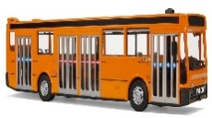

C
坐火车
zuò huǒchē

BA
坐飞机
zuò fēijī
A
B
2
3
1
D

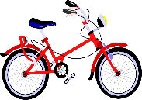

F
坐 船
zuò chuán

E
坐公共汽车
zuò gōnggòng qìchē

D
开 车
kāichē
1. ___________
2. ___________
3. ___________

b. Activities you usually do at the weekends. Write down the Chinese for them.

1.watch films | 2.go to lunch | 3. go to the park | 4.go shopping | 5. go to the library  LIBRARY | 6. go to the gym  GYM
1.看电影  kàn diànyǐng | 2._________ | 3._________ | 4._________ | 5._________ | 6._________

Contributed by Zhou Hong ， King Edward VII Academy
Suggested answer:
The two activities are meant to help the students to practice the vocabulary of weekend plans. The first one is to practice the means of transportation by playing a card game. The second one is to practice the activities to do in the weekends.
a. 1. F 2. C 3. E
b. 2. 吃午饭 3. 去公园 4. 买东西 5. 去图书馆 6. 去运动中心

