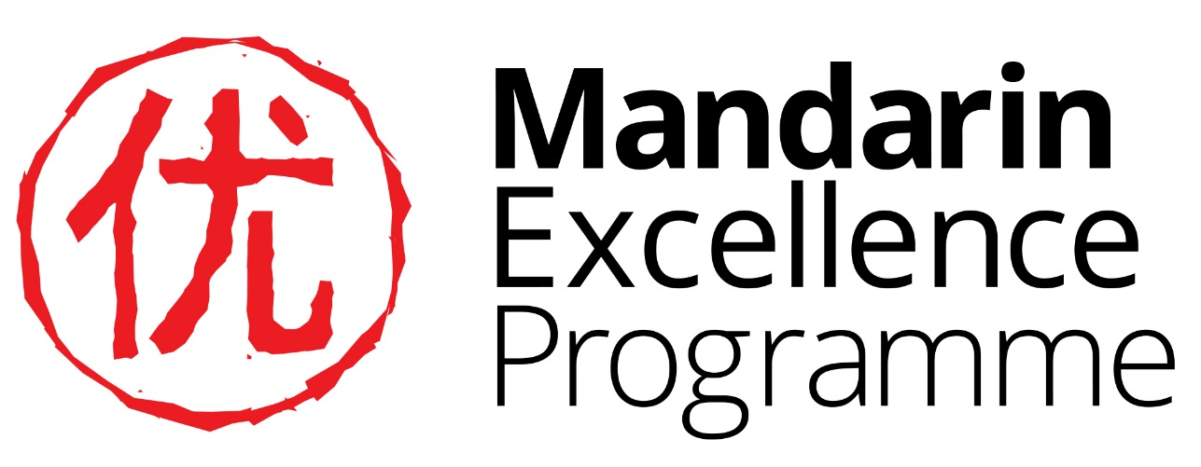

Y9 Project: Qiu Jin: Heroine and Revolutionary Martyr

Answers
Task 1

- 一八七五年
- Queen Victoria
- The writer’s name is Lǔ Xùn 鲁迅 His most famous books include: Diary of a Madman 狂人日記 (kuáng rén rì jì); The True Story of Ah Q 阿Q正传 (ā Q zhèng zhuàn) and a collection of short stories Outcry吶喊 nà hǎn
- The Qing dynasty 清 (qīng, ‘bright, clear’) The dates are: 从一六四四年到一九一一年

- Japan 日本 rì běn
- 三十一岁
Task 2

竞 | jìng | to compete against
雄 | xióng | male
女 | nǚ | woman
侠 | xiá | warrior
秋 | qiū | autumn (surname)
瑾 | jǐn | precious jade (name)

Task 4
(Your answers need not be the same as these, these are suggested answers)

记者：（jì zhě ‘journalist’） 你是哪年出生的？

秋瑾：我是一八七五年出生的
记者：你在哪儿长大了？

秋瑾：我在绍兴长大了
记者：你有孩子吗？

秋瑾：我有两个孩子， 一个男孩儿， 一个女孩儿
记者：你在哪儿留学？多长时间？ （留学 liú xué ‘to study abroad’）
秋瑾：我在日本留学了三年

- 记者：你学了什么课？你喜欢什么课？

秋瑾：除了文学以外，我也学了武术和骑马。 我非常喜欢骑马
- 记者：你为什么支持男女平等? （支持zhī chí ‘to support,’）

秋瑾：因为我觉得如果没有男女平等， 中国不能成为一个现代的国家

Task 5a

Surname (姓 xìng) | Meaning in English
安 (ān) | peace
宝 (bǎo) | treasure
丁 (dīng) | man
胡 (hú) | beard
雷 (léi) | thunder
毛 (máo) | hair
王 (wáng) | king

Task 5b
老百姓 lǎo bǎi xìng
- What is the literal (word for word) translation of that phrase?
‘Old hundred surnames’

- What does the expression refer to?
The common people, ordinary people

Task 5c
周 | 卢 | 秦 | 杨 | 孟 | 谭 | 苏 | 商 | 丘 | 刘
明 | 李 | 马 | 吕 | 林 | 黄 | 利 | 陈 | 蓝 | 孔
张 | 金 | 蒋 | 赵 | 霍 | 侯 | 吴 | 韩 | 黄 | 石
海 | 郭 | 阮 | 管 | 周 | 方 | 杜 | 习 | 徐 | 燕
谢 | 杨 | 梅 | 英 | 宗 | 沈 | 杨 | 宋 | 张 | 禹
闻 | 华 | 陈 | 叶 | 王 | 鱼 | 熊 | 谷 | 楚 | 王
刘 | 曹 | 唐 | 李 | 宫 | 白 | 吴 | 牛 | 赵 | 童
鲁 | 黄 | 齐 | 年 | 和 | 吴 | 冷 | 周 | 江 | 左
桂 | 姚 | 赵 | 古 | 陈 | 范 | 罗 | 庄 | 邓 | 花
张 | 贾 | 王 | 晋 | 魏 | 陶 | 刘 | 康 | 苗 | 李

Sima Qian (司马迁 sī mǎ qiān) a historian, 145-86 BCE, he is considered to be China’s greatest historian; his book, which covers almost 2000 years of history, is still considered an important source for the study of China’s early history.

Task 7

 | Line number
沉沉女界有谁援 | 2
放足湔除千载毒 | 5
日月无光天地昏 | 1
骨肉分离出玉门 | 4
可怜一副鲛绡帕 | 7
钗环典质浮沧海 | 3
热心唤起百花魂 | 6
半是血痕半泪痕 | 8

Task 7
- The Northern Wei dynasty
- Archery, horse riding and martial arts
- Her elderly father had been sent off to war
- 4 siblings
- 12 years

- 老大 lǎo dà
- （独自）一个人 (dú zì) yī gè rén
- 皇帝 huáng dì
- 女儿装 nǚ er zhuāng
- 目eyes 瞪 open, glare 口 mouth 呆 blank, slow witted

