

**Difficulty**

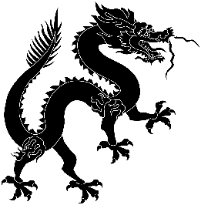

**Predicted Duration**

3 hours 40 minutes

**Series Type**

History

Teachers’ Notes

Y9 Project: Qiu Jin

*This topic introduces students to a fascinating figure in Chinese history, as well as giving them some background to the half century of revolution that gave birth to modern China. There are research tasks as well as language tasks and two Chairman’s Bao features to boost listening and reading skills. Some of the writing tasks involve forming questions, a vital and sometimes overlooked skill in language acquisition. The task linked to a poem will give your students practice in using authentic texts. Chinese surnames can sometimes be a stumbling block for learners and this project includes a task to familiarise learners with the most common ones. Hopefully this project will whet your students’ appetites for learning more about China’s history.*

|  |  |
| --- | --- |
| Task Number | Est. time to complete |
| Task 1: Who was Qiu Jin? | 20 mins |
| Task 2: Qiu Jin – the movie | 40 mins |
| Task 3: Describing a picture | 30 mins |
| Task 4: Qiu Jin in the hot seat | 30 mins |
| Task 5: A look at Chinese surnames | 20 mins |
| Task 6: What was ‘foot binding’? | 30 mins |
| Task 7: A poem | 15 mins |
| Task 8: Women warriors in Chinese history | 20 mins |
| Task 9: Reviewing the project | 15 mins |
|  | 3 hours 40 mins |

|  |  |
| --- | --- |
| Key Vocabulary | |
| 清代qīng dài | the Qing dynasty |
| 留学 liú xué | to study abroad |
| 支持zhī chí | to support |
| 武术 wǔ shù | martial arts |
| 骑马 qí mǎ | horse riding |
| 文学wén xué | literature |
| 男女平等 nán nǚ píng děng | equality of the sexes |
| 现代的xiàn dài de | modern |
| 成为 chéng wéi | to become |
| 练习 liàn xí | exercise/task |
| 难 nán | difficult |
| 有意思 yǒu yì si | interesting |
| 没意思 méi yì si | boring |