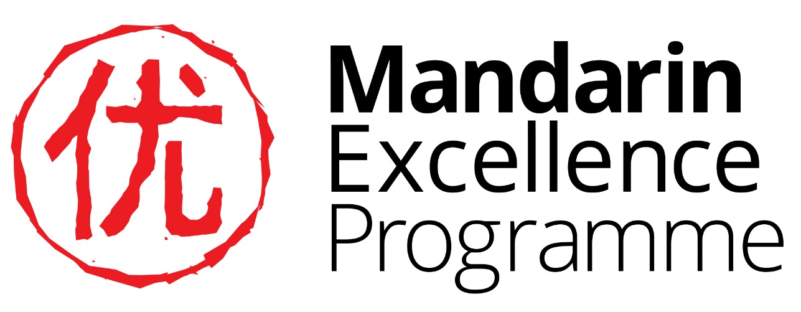

Y9 Project: The Forbidden City

Answers

Task 1

zǐ jìn chéng (Purple Forbidden City): 紫禁城
gù gōng （former palace）： 故宫
- Why was it called ‘forbidden’? No one could enter or leave without the emperor’s permission
- Emperors of which two dynasties lived in the Forbidden City? the Ming dynasty and the Qing dynasty
- When was it named a UNESCO World Heritage Site? 1987

Numerical fact | Number in Chinese
The Forbidden City took 14 years to build | 十四
A million workers built it | 百万
One hundred thousand craftsmen were involved | 十万
It has 980 buildings | 九百八十
There are 8,700 rooms | 八千七百
14 million visitors enter every year | 十四百万
80,000 visitors enter every day | 八万

Task 2a
- What do the characters in feng shui mean? wind, water
- What English word beginning with ‘g’ have some people used to translate feng shui? geomancy
Task 2b

The Palace of Obeying Heaven | 在the Palace of Everlasting Harmony | 西边
The Imperial Kitchen | 在the Hall of Mental Cultivation | 南边
The Hall of Literary Brilliance | 在the Gate of Supreme Harmony | 东边
The Hall of Ultimate Supremacy | 在the Pavilion of Rain and Flowers | 东边
The Pavilion of Extended Spring | 在the Glory Palace | 东边
The Spiritual Valor Gate | 在the Hall of Imperial Peace | 北边
The Hall of Military Glory | 在the Internal Affairs Department | 南边

2b.4
宫 | gong palace, temple |  | 殿 | diàn hall, palace, temple |  | 門 | mén gate

Palace of Eternal Harmony |  | 长春宫
The Hall of Mental Cultivation |  | 永和宫
Palace of Eternal Spring |  | 养心殿
The Gate of Supreme Harmony |  | 中和殿
The Hall of Middle Harmony |  | 太和門
2b.6 This tablet has been translated several ways for example: "let the righteous shine" It has come to mean "to be decent, honest and magnanimous," or "to have no secret or do a shameless deed."

2b.7 Lego 乐高 lè gāo

Task 3 Symbols everywhere

Symbol | 中文 and pinyin | What the symbol represented
Dragon | 龙 lóng | The Emperor
Phoenix | 凤 (fèng)  凤凰 (fèng huáng) | The Empress, also peace and prosperity. The dragon and phoenix together symbolise a perfect marriage.
Turtle | 龟 (gūi) | wisdom, endurance, long life
Crane | 鹤 (hè) | Long life (longevity), the hope of becoming a high official.
Lion | 狮子 (shī zi) | Power
Unicorn | 麒麟 (qí lín) | luck, protection, long life, success, fertility, prosperity, the birth of a sage or ruler

- Why were the roof tiles yellow? Yellow was the colour of the emperor. Only imperial family members and their relatives could live in residences with yellow-coloured glazed tile roofs.

- Which building’s roofs are the only ones with 9 animal statues on them? The imperial throne hall. Only official buildings were allowed to have animal statues on the roof, ranging from one to nine in importance. Nine, the highest number, was reserved for the most important building in the empire.

Task 7 Spooky stories from the Forbidden City

Task 7a

Correct number
4. | 走路三个小时以后，我开始觉得又热又累
7. | 我站起来，走来走去，什么出口都找不到
11. | 她只对我说一个字“来！” 我就随着她走了
8. | 我突然见到了一个女人
12. | 她走到一个门口，让我出去
1. | 我是一个英国学生， 上十年级，中文学了四年了
3. | 有一天我们去参观北京故宫，天气非常热
14. | 最后，我们导游对我说“肯定是故宫的一个鬼帮助你了！”
13. | 我回头要对她说 “谢谢”， 她已经消失了
2. | 去年我们班去了中国旅行
10. | 最奇怪的是虽然没有下雨，她的衣服却湿淋淋
6. | 一觉醒来，我发现天黑了，一个人都没有。故宫关门了！
9. | 她的衣服很奇怪， 她穿着白色的长衣
5. | 我在一个安静的墙角坐下来休息，马上要睡觉了！

Task 7b
Don’t worry if your translation is not exactly the same as the suggested one below:

A spooky story from the Forbidden City: My translation

- I am an English student in Year 10, I’ve been studying Chinese for 4 years.
- Last year our class went travelling in China
- One day we went to visit the Forbidden city in Beijing, the weather was really hot.
- After walking for three hours, I began to feel hot and tired
- I sat down to rest in a quiet corner and immediately fell asleep.
- When I woke up I discovered that it was dark and no one ws there. The Forbidden City had closed!
- I stood up, walked to and fro but couldn’t find any exit.
- Suddenly I saw a woman.
- Her clothes were strange, she wore a long white robe.
- The strangest thing was that although it hadn’t rained, her clothes were wet.
- She said just one word to me “Come!” I followed her.
- She walked towards and gate and let me go out.
- I turned to say ‘thank you’ to her, but she had disappeared.
- Afterwards, our guide said to me “It must have been a ghost of the Forbidden City who helped you.”

Task 8
- Write his name here in Chinese characters and pin yin

毛泽东 máo zé dōng
- He is also known as 毛主席 . Write the pin yin and the English translation of this.

毛主席 máo zhǔ xí Chairman Mao
- Copy the Chinese characters on the red poster either side of his portrait and translate them into English.
中华人民共和国万岁， 世界人民大团结万岁

“Long live the People’s Republic of China, long live the great unity of the people of the world.”
- A new version of the portrait is hung up every year on the same day. What day is that and why is it significant?

October 1st, China’s National Day, the anniversary of the day in 1949 when Mao stood on balcony above where his portrait now hangs to declare the foundation of the People’s Republic of China.

