

**Difficulty**

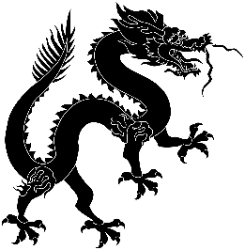

**Predicted Duration**

4 hours 45 minutes

**Series Type**

History and Culture

Teachers’ Notes

Y9 Project: The Forbidden City

*This project will hopefully spark your students’ interest in the history of China. The projects tasks introduce them to the Forbidden City, its layout and its history. They will learn about important Imperial symbols and the story of Pu Yi, the Last Emperor. Language tasks help them revise directions in Chinese and there is a substantial reading and translating challenge with a short spooky story.*

|  |  |
| --- | --- |
| Task Number | Est. time to complete |
| Task 1: A few facts | 30 mins |
| Task 2: Exploring the Forbidden City | 45 mins |
| Task 3: A very special tour | 30 mins |
| Task 4: Symbols everywhere | 30 mins |
| Task 5: The Last Emperor | 20 mins |
| Task 6: Little Dog Emperors? | 30 mins |
| Task 7: Spooky Stories from the Forbidden City | 1 hour |
| Task 8: A symbol of Modern China | 20 mins |
| Task 9: Review | 10 mins |
|  | 4 hours 45 mins |

|  |  |
| --- | --- |
| Key Vocabulary | |
| 百 bǎi | 100 |
| 千 qiān | 1,000 |
| 万 wàn | 10,000 |
| 亿 yì | 100 million |
| 东边 dōng biān | east |
| 西边 xī biān | west |
| 南边 nán biān | south |
| 北边 běi biān | north |