

**Difficulty**

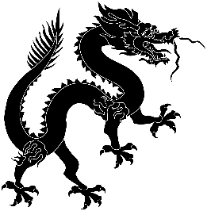

**Predicted Duration**

4.5 hours

**Series Type**

Travel and Tourism

Teachers’ Notes

Y9 Project: Space and Sci-Fi

*Practising vocabulary and expressions about travel and tourism is key to students’ exam preparation as well as being an extremely useful aspect of language learning. By focussing on the city of Paris, students will get a slightly different angle on this topic as well as gaining an insight into one of the world’s most popular destinations for Chinese tourists. There are creative tasks (such as the travel vlog) and opportunities for revision for example times, world cities and giving directions. The task about three Chinese residents of Paris will give them an introduction to some key aspects of China’s recent history.*

|  |  |
| --- | --- |
| Task Number | Est. time to complete |
| Task 1: Key words | 30 mins |
| Task 2: Giving directions | 30 mins |
| Task 3: TCB: Packing instant noodles | 30 mins |
| Task 4: Tips on Travel from a Chinese Vlogger | 60 mins |
| Task 5: Three famous Chinese residents of Paris | 40 mins |
| Task 6: TCB: A contemporary Chinese artist in Paris | 30 mins |
| Task 7: A pretend Paris | 20 mins |
| Task 8: Taking the flight home | 20 mins |
| Task 9: Reviewing the project | 10 mins |
|  | 4.5 hours |

|  |  |  |
| --- | --- | --- |
| Key Vocabulary | | |
| 走路 | zǒu lù | to walk |
| 分钟 | fēn zhōng | minute (of time) |
| 车站 | chē zhàn | bus stop |
| 假 | jiǎ | false |
| 真 | zhēn | true |
| 左右 | zǔo yòu | approximately |