

**Difficulty**

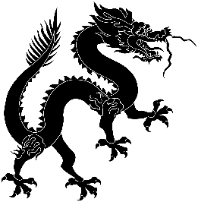

**Predicted Duration**

4 hours

**Series Type**

Education

Teachers’ Notes

Y9 Project: Gaokao

*This project will help your students revise vocabulary to do with school and give them a deeper insight into the experience of Chinese students and the Gaokao exam.*

*There are research tasks as well as language tasks including dictionary work, numeracy revision and a chance to enjoy part of a movie. There are two writing tasks: a message writing exercise that will improve their use of conversational language and a picture description. Both of these involve forming questions, a vital and sometimes overlooked skill in language learning. There are two Chairman’s Bao features to boost listening and reading skills. The section on the Imperial exam system will help your students learn more about Chinese history and the linked poetry task will give your students practice in using authentic texts.*

|  |  |
| --- | --- |
| Task Number | Est. time to complete |
| Task 1: The name of the exam | 30 mins |
| Task 2: Talking about the Gaokao | 45 mins |
| Task 3: TCB: A big send-off for Gaokao students | 30 mins |
| Task 4: Romance and the Gaokao don’t mix! | 30 mins |
| Task 5: The battle against the cheats | 20 mins |
| Task 6: TCB: Keeping up morale | 30 mins |
| Task 7: Describing a picture | 20 mins |
| Task 8: Imperial China’s make-or-break exam | 20 mins |
| Task 9: Reviewing the project | 15 mins |
|  | 4 hours |

|  |  |
| --- | --- |
| Key Vocabulary | |
| 高考gāo kǎo | the Gaokao |
| 考试 kǎo shì | to take an exam |
| 小时xiǎo shí | hour |
| 百分之 bǎi fēn zhī…. | percentage |
| 打牌 dǎ pái | to play cards |
| 有时yǒu shí | sometimes |