

**Difficulty**

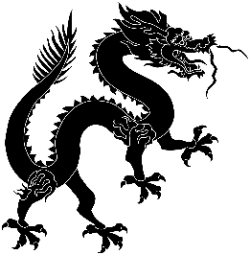

**Predicted Duration**

4 hours

**Series Type**

Technology

Teachers’ Notes

Y9 Project: Space and Sci-Fi

*Many students are fans of science fiction, so hopefully they will enjoy this project. The first section focuses on the solar system and space travel. There are tasks involving dictionary work and research. An article from The Chairman’s Bao links the Chinese lunar programme with cultural references to Chang E and the rabbit on the moon. In terms of writing, there is an exercise to practise using* 将*. The second half concentrates on Science Fiction. There is an exercise to help your students revise their knowledge of radicals and there is the challenge of an authentic text, Lao She’s Cat Country. The second Chairman’s Bao article will appeal to Dr Who fans and the final task provides an amusing way of practising listening by watching Pepper Pig in Mandarin!*

|  |  |
| --- | --- |
| Task Number | Est. time to complete |
| Task 1: The Solar System | 30 mins |
| Task 2: China’s space programme | 30 mins |
| Task 3: TCB: China’s mission to the moon | 30 mins |
| Task 4: Talking about the future using 将 | 30 mins |
| Task 5: Science Fiction ‘Sci Fi’ | 20 mins |
| Task 6: TCB: The Tardis lands in China! | 30 mins |
| Task 7: Cat Country: Early Sci-Fi from China | 30 mins |
| Task 8: 小猪佩奇 goes to the moon | 30 mins |
| Task 9: Reviewing the project | 10 mins |
|  | 4 hours |

|  |  |  |
| --- | --- | --- |
| Key Vocabulary | | |
| 地球 | dì qiú | Eart |
| 月球 | yuè qiú | the moon |
| 太空 | tài kōng | space |
| 衣服 | yī fu | clothes |
| 手 | shǒu | hand |
| 脚 | jiǎo | foot |
| 外国人 | wài guó rén | foreigner |
| 飞机 | fēi jī | aircraft |
| 讲 | jiǎng | to say, talk about |